***Practical 4: To determine maximum temperature using Hadoop MapReduce***

Dataset – temperature.txt

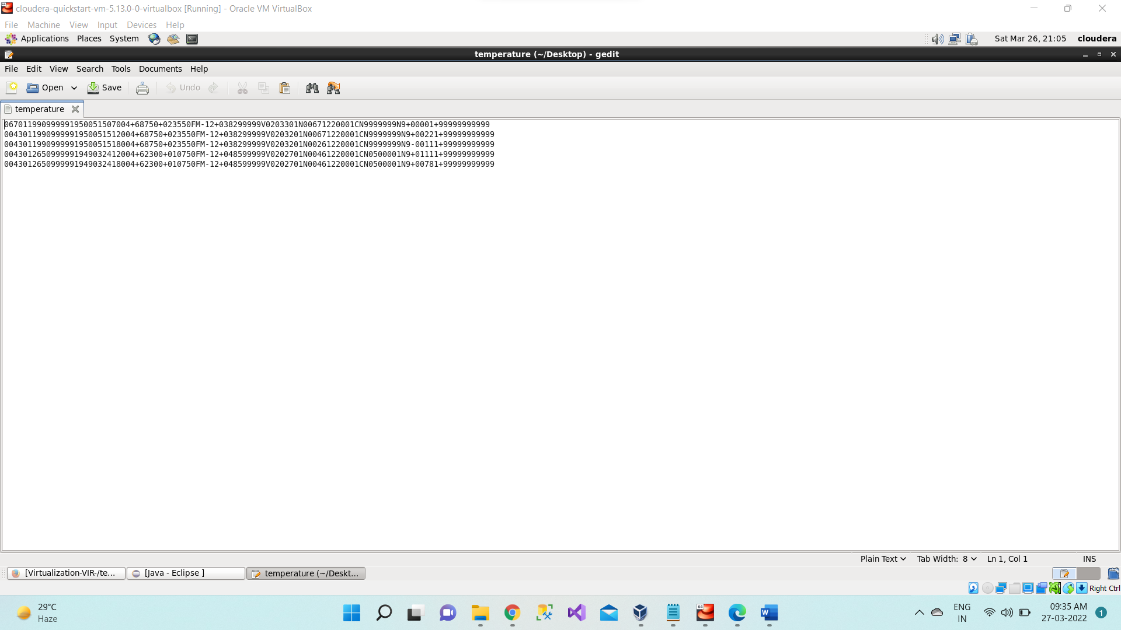



Steps to determine maximum temperature using Hadoop MapReduce in Cloudera:

**Step 1:** Open virtual box and then start cloudera quickstart



**Step 2:** Open Eclipse present on the cloudera desktop

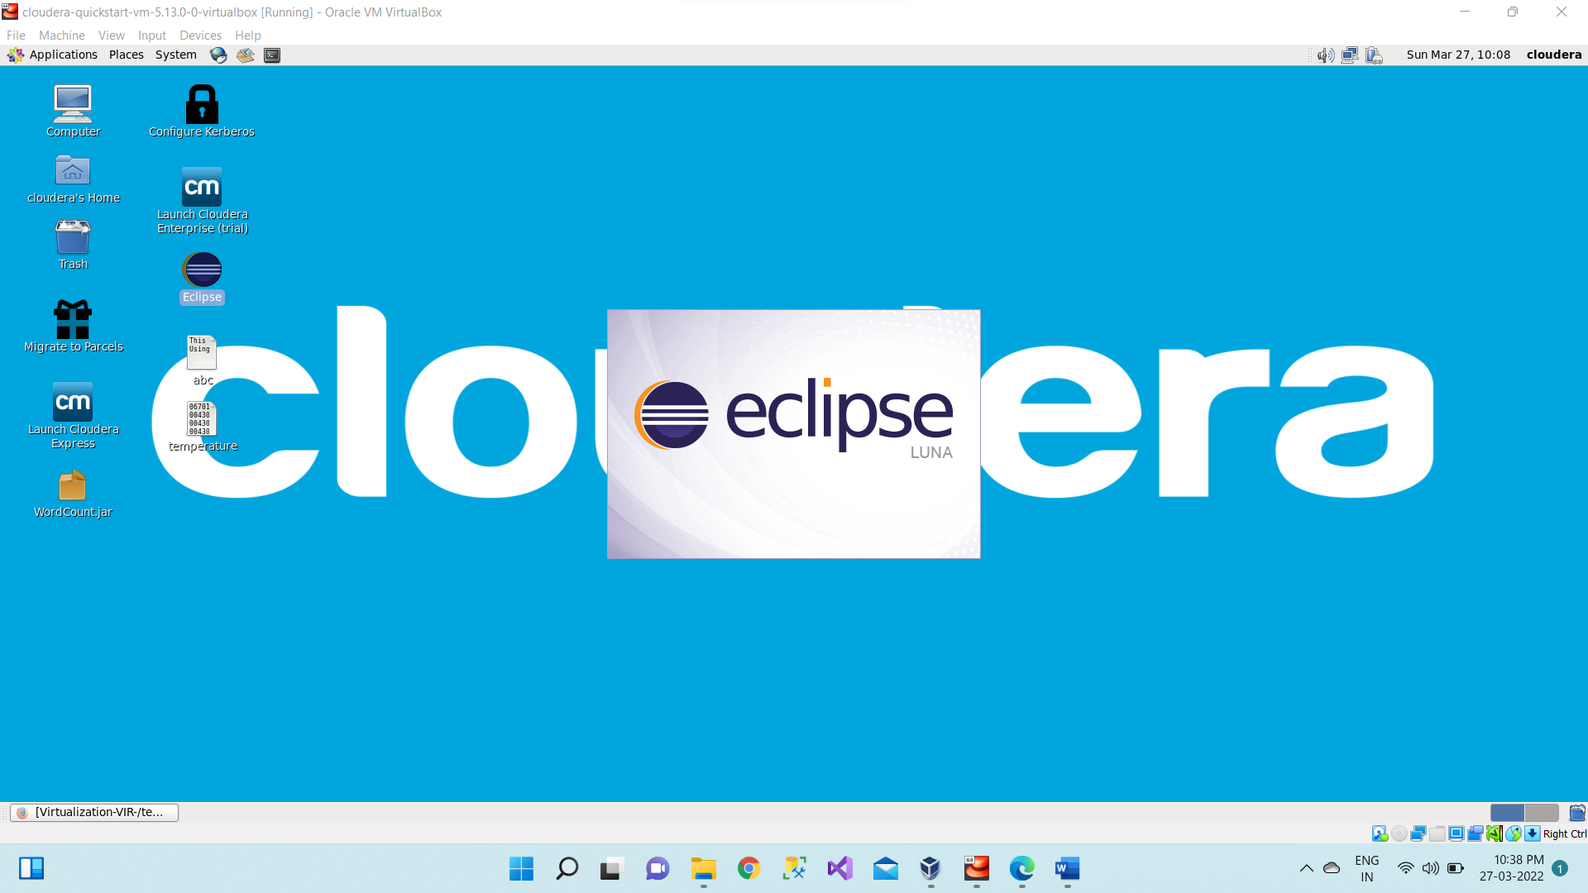

**Step 3:** Create a new Java project clicking: File -> New -> Project -> Java Project -> Next (“MaxTemp” is the project name).

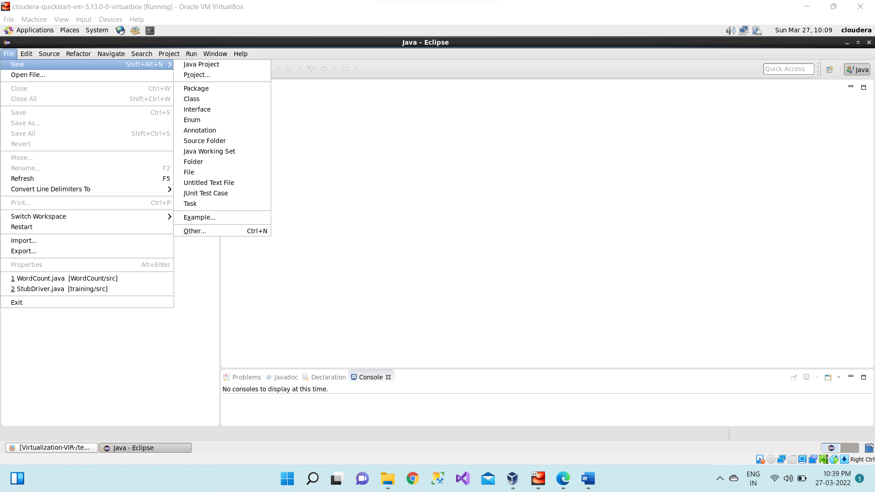

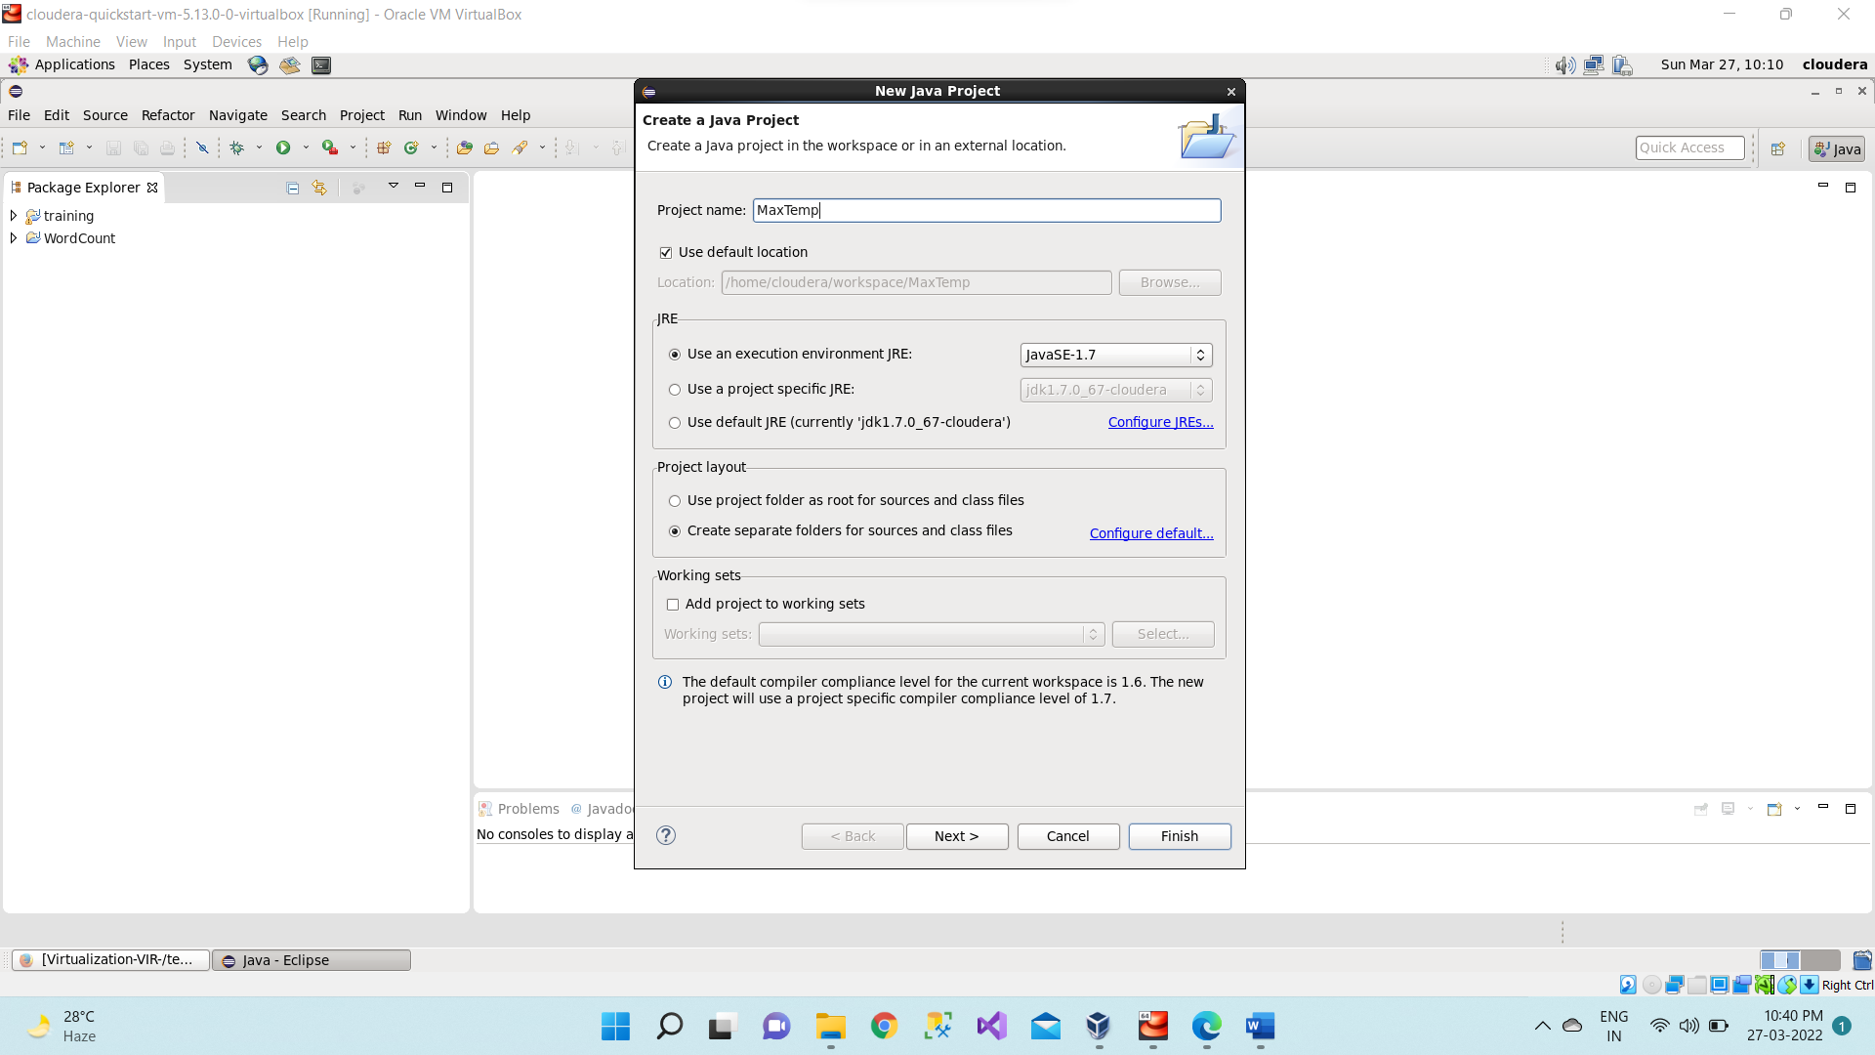

**Step 4:** Adding the Hadoop libraries to the project Click on Libraries -> Add External JARs Click on File System -> usr -> lib -> hadoop Select all the libraries (JAR Files) -> click OK Click on Add External jars, -> client -> select all jar files -> ok -> Finish

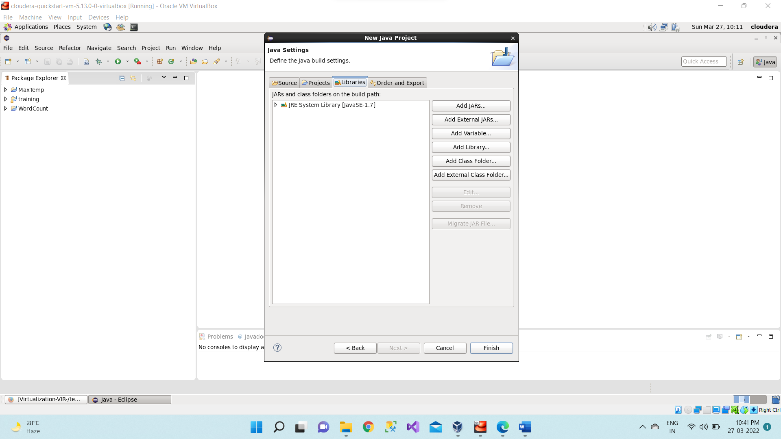

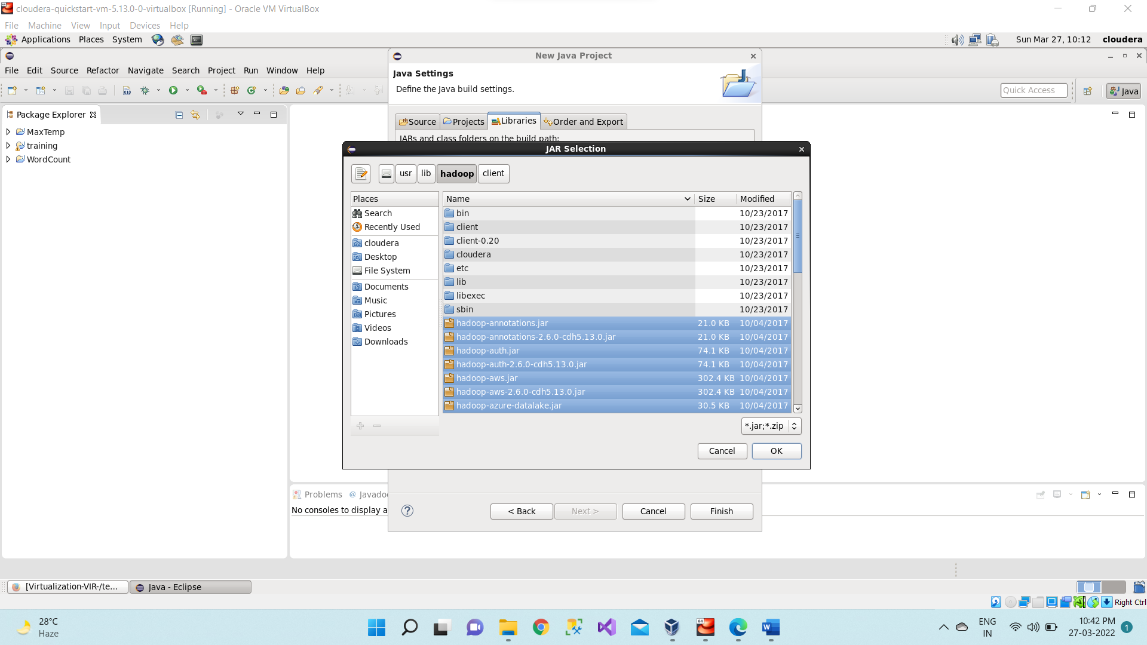

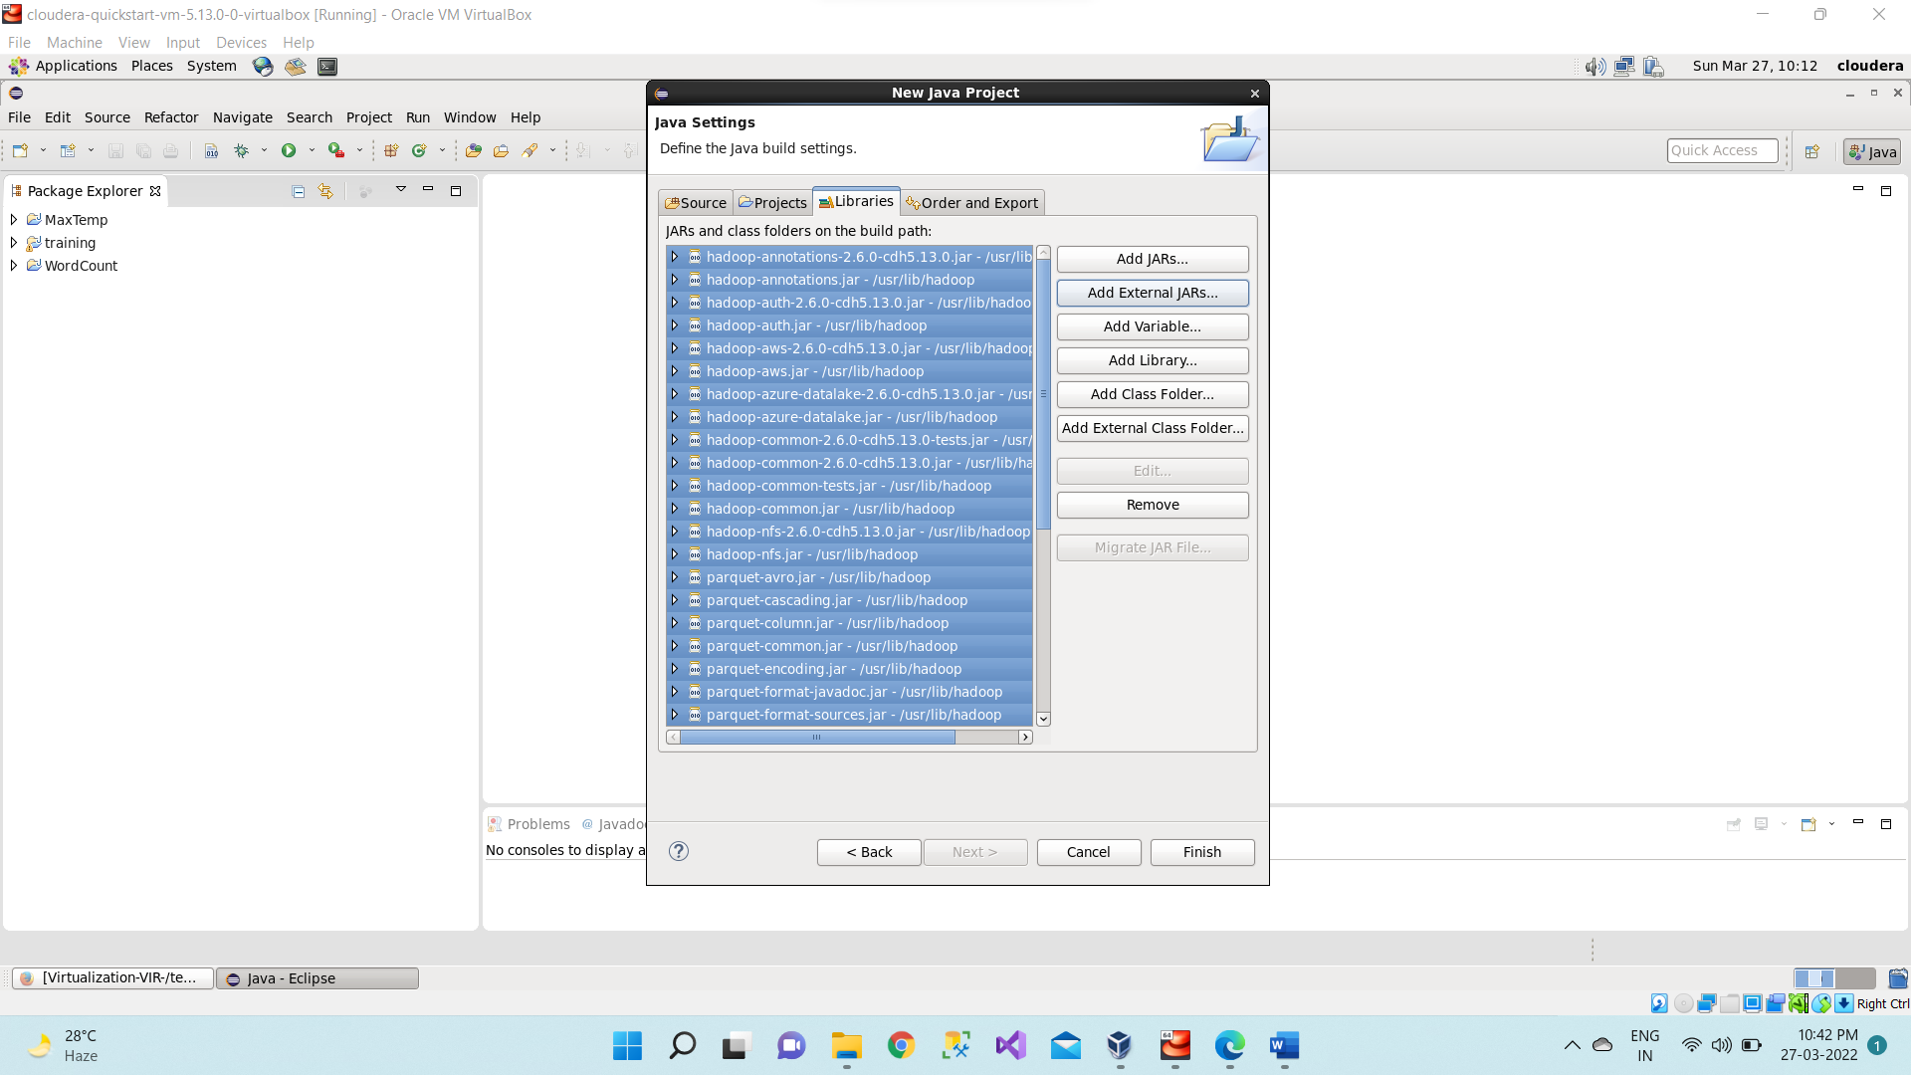

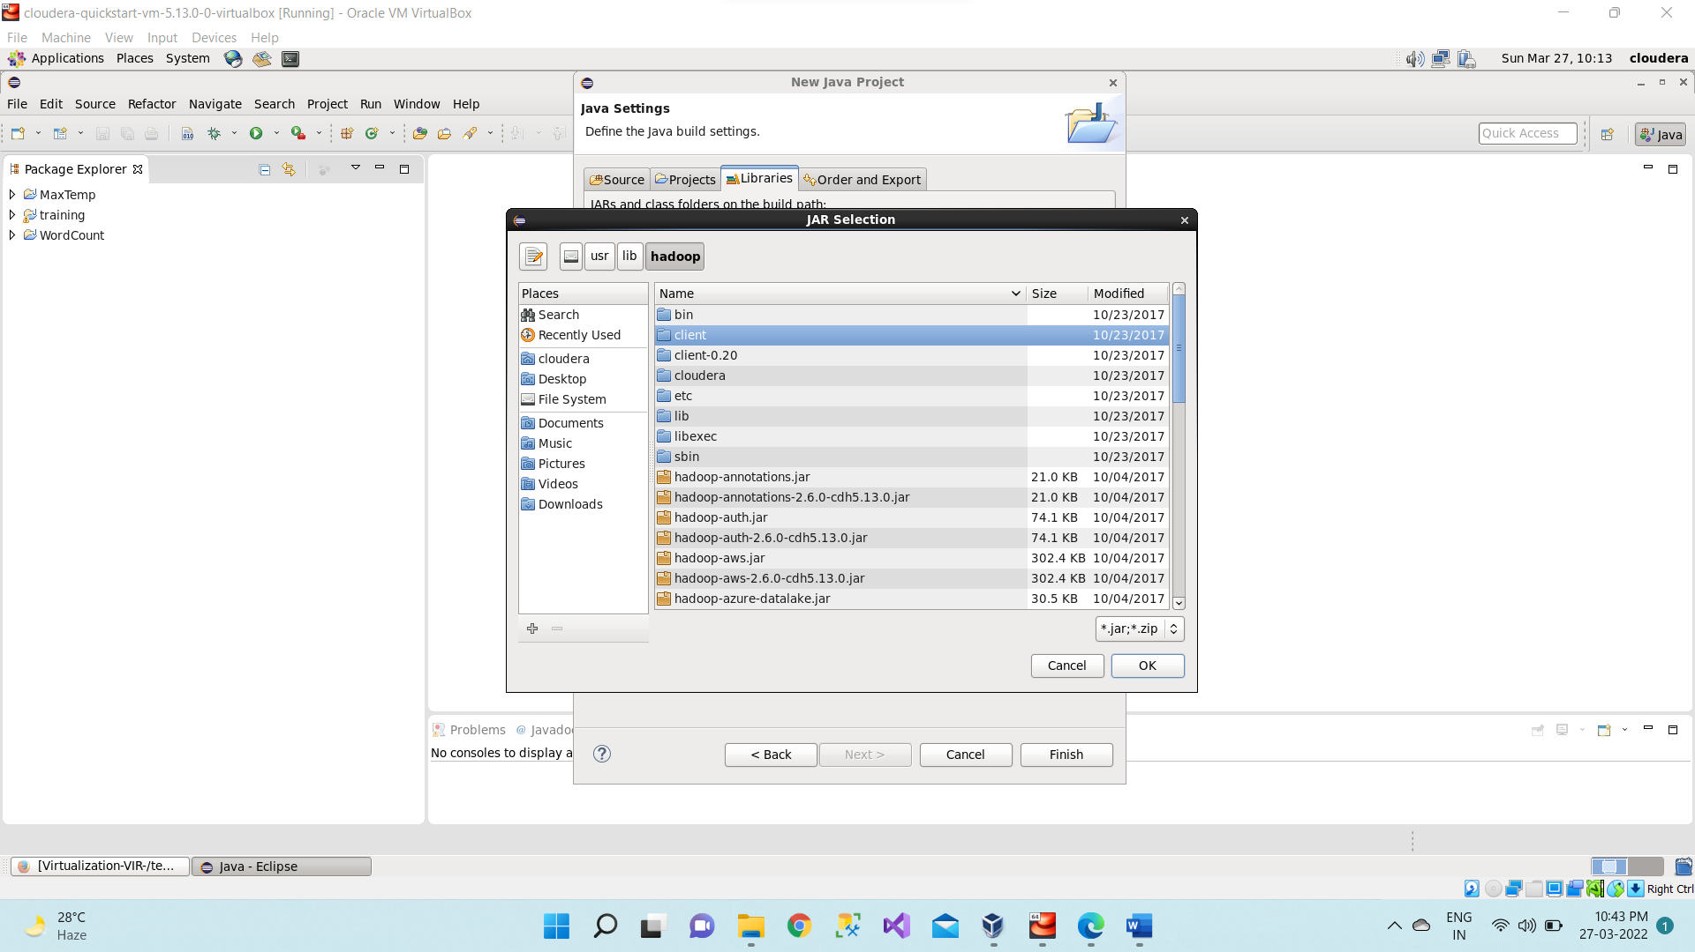

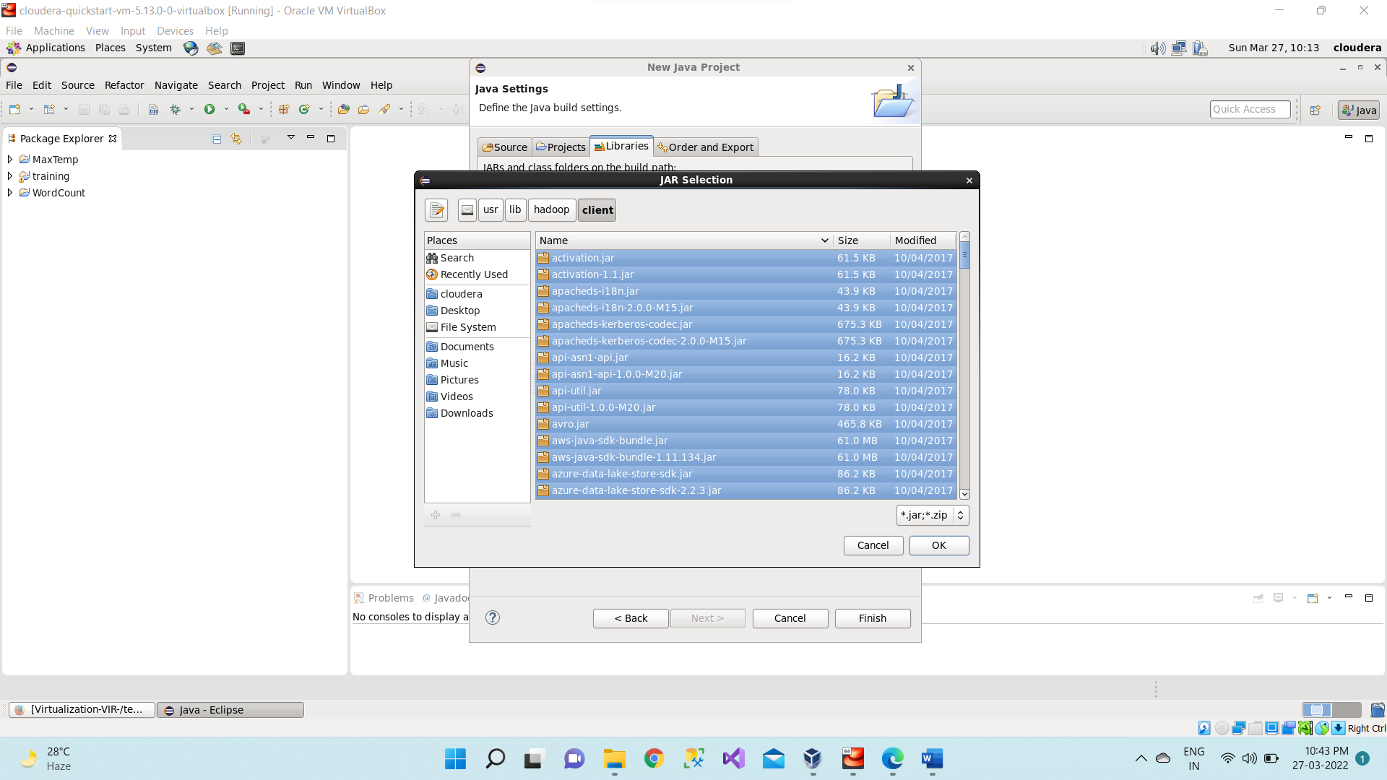

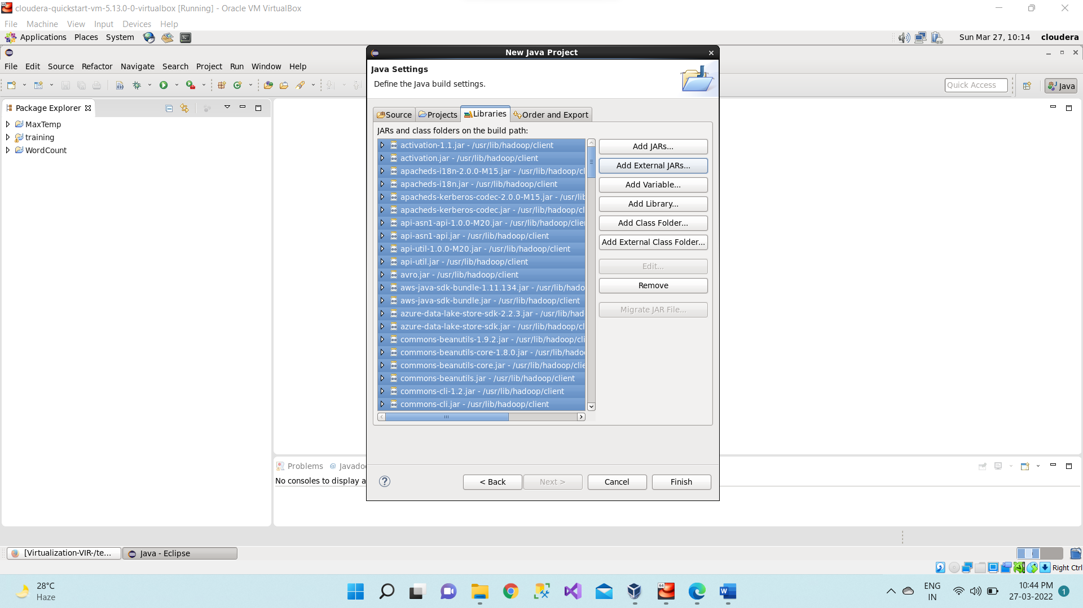

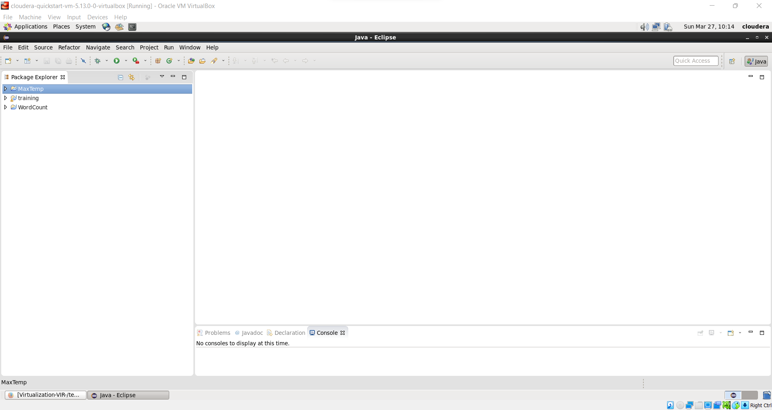

**Step 5:** Right Click on the name of Project “MaxTemp” -> New -> class Don’t write anything for package Write Name Textbox write “MaxTemp” -> Finish Then MaxTemp.java window will pop up

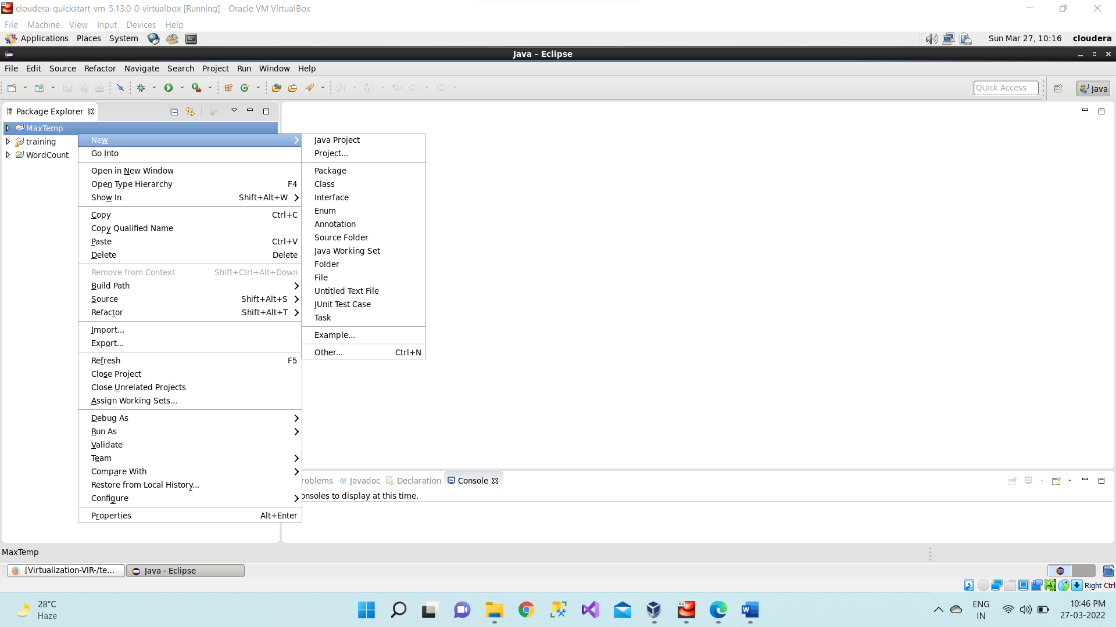

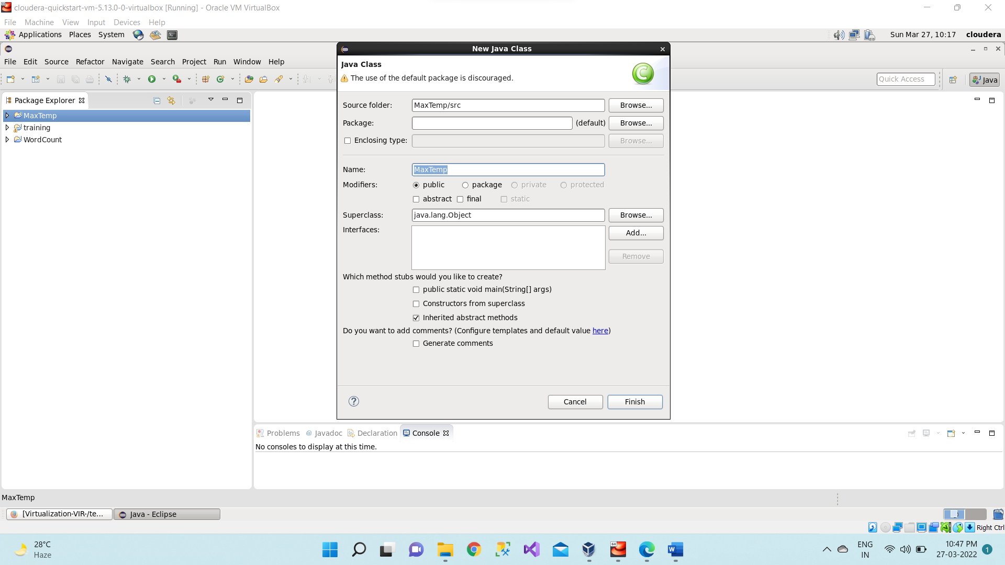

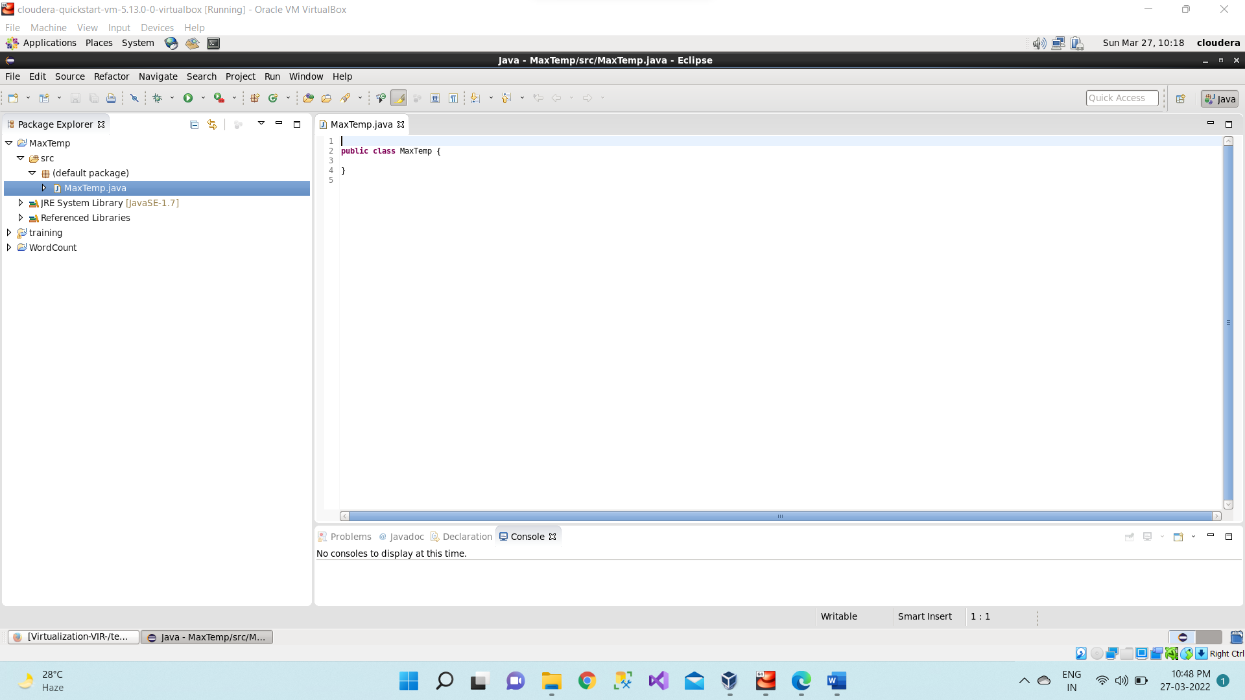

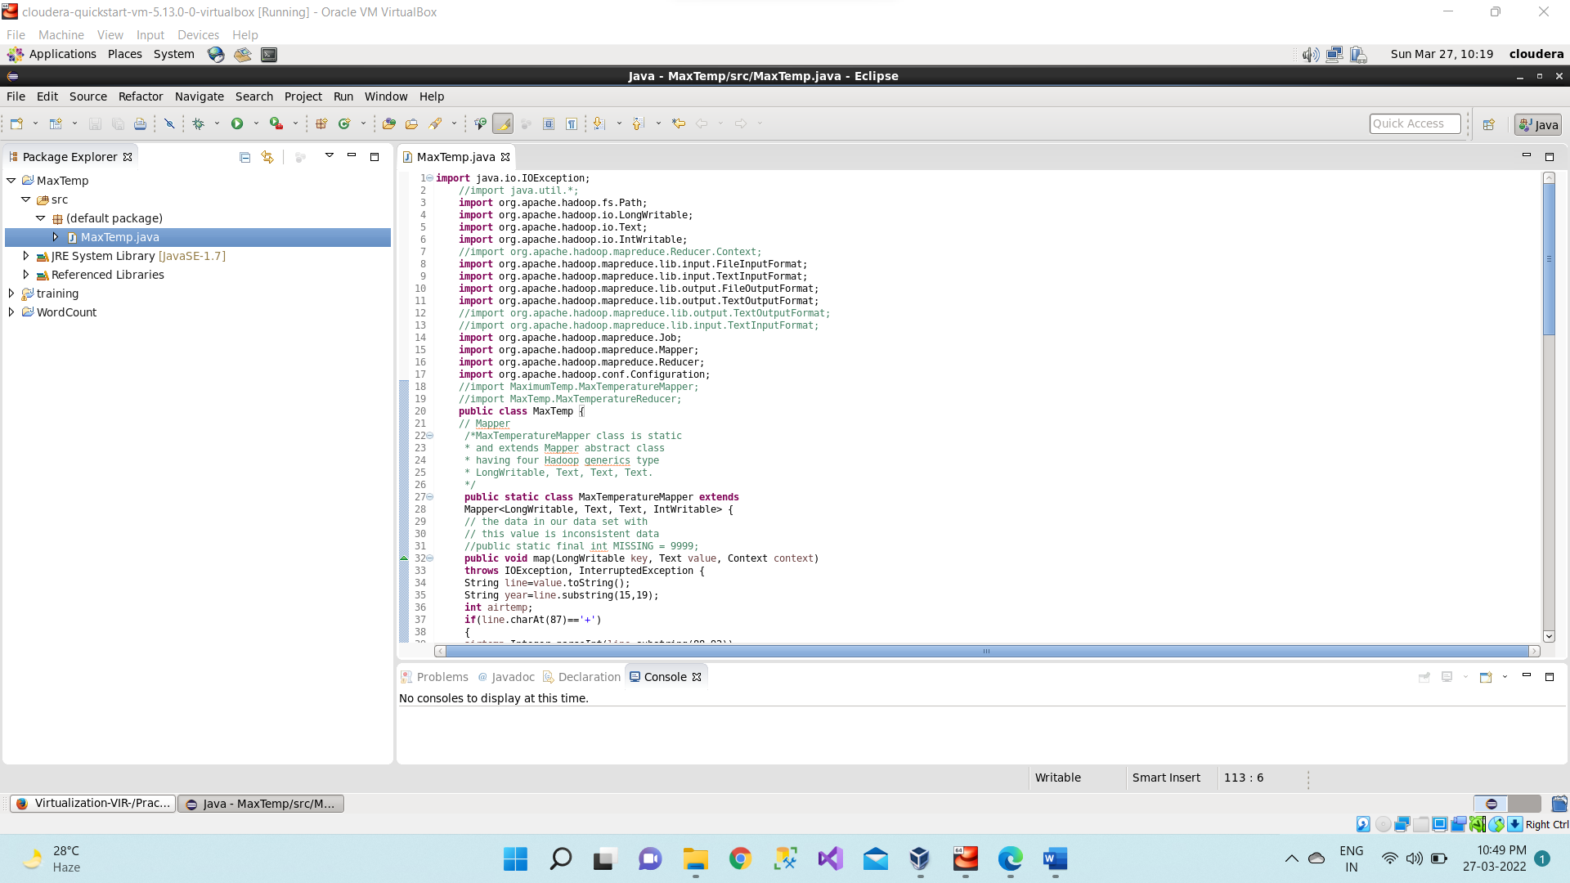

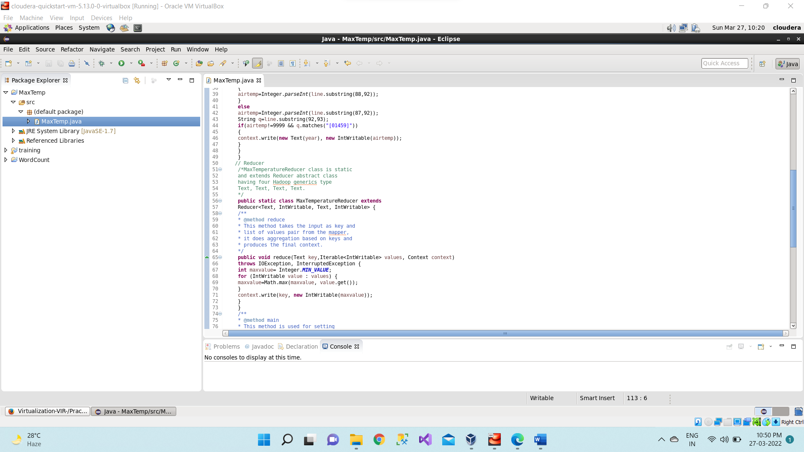

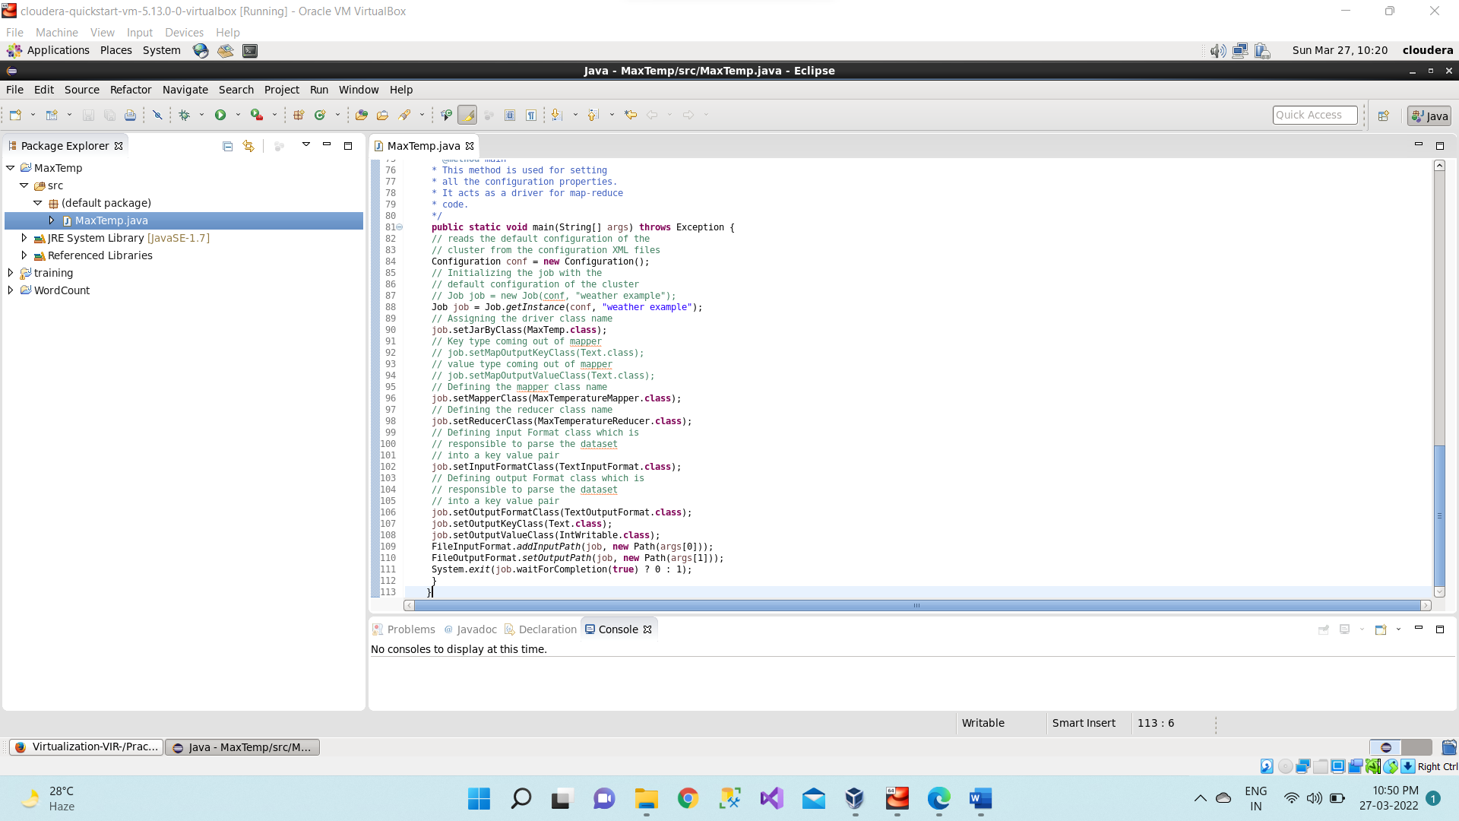

**Step 6:** Right Click on the project name MaxTemp -> Export -> Java -> JAR File -> Next -> for select the export destination for JAR file: browse -> Name: MaxTemp.jar -> save in folder - > cloudera -> Finish -> OK

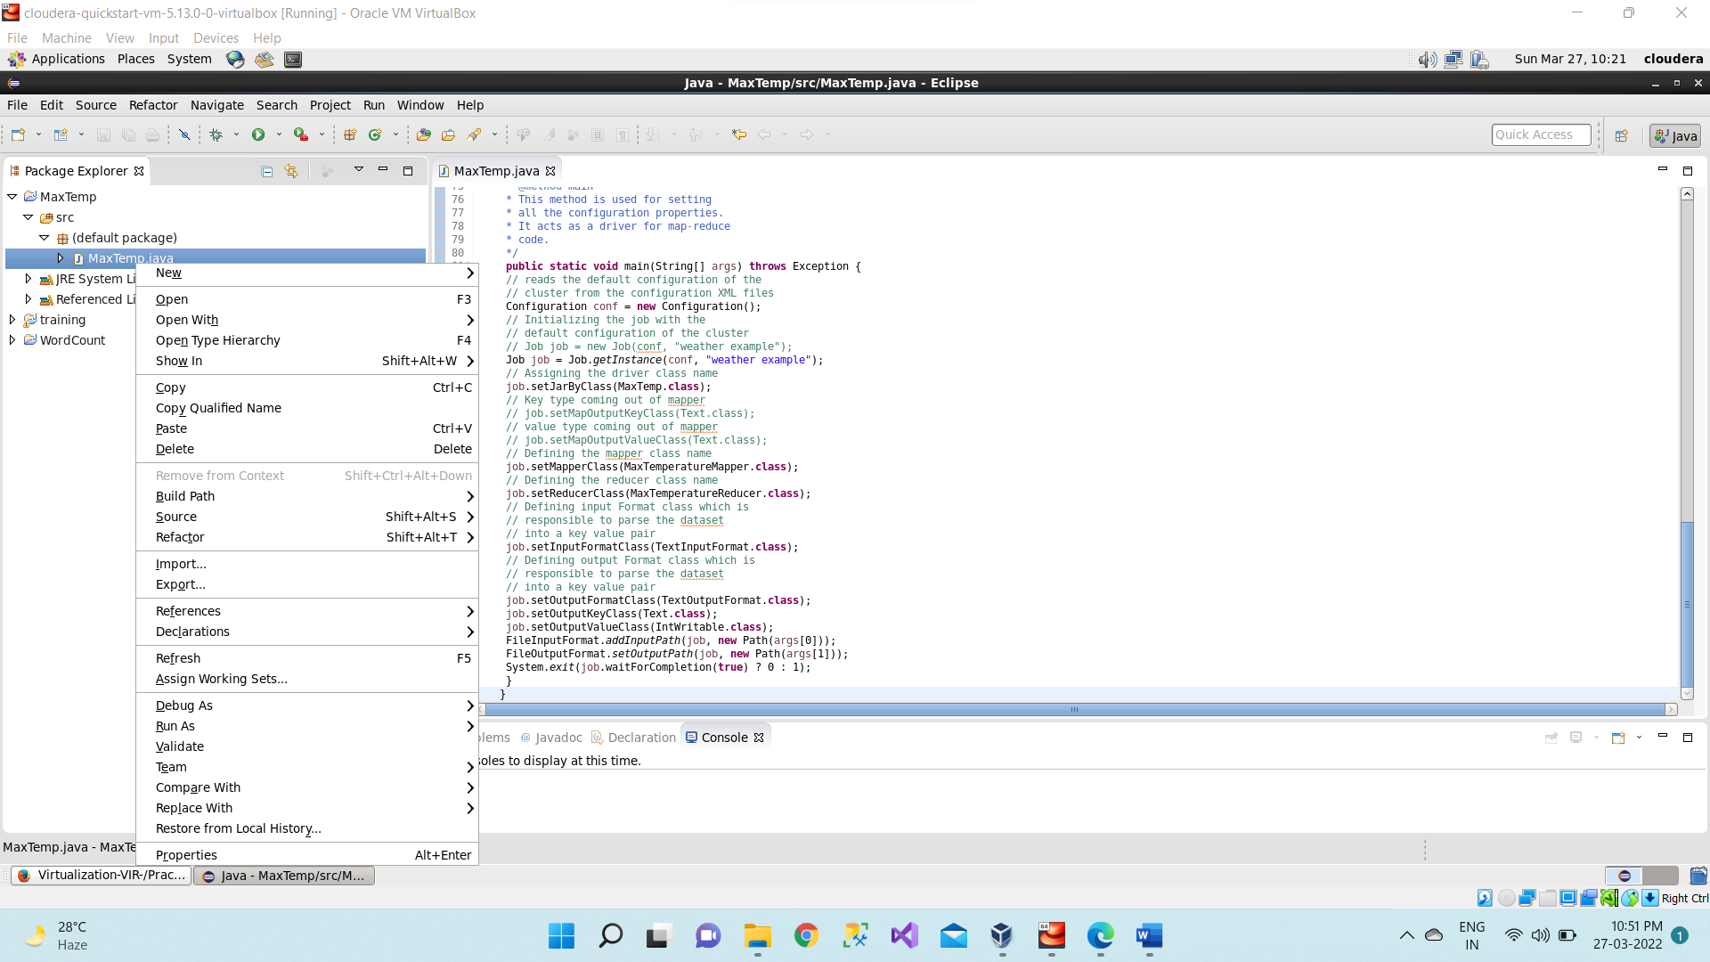

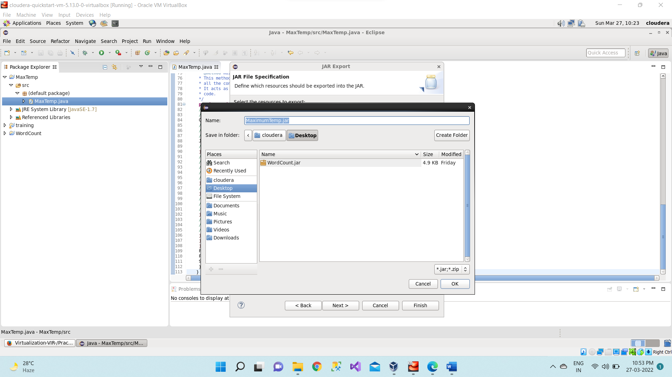

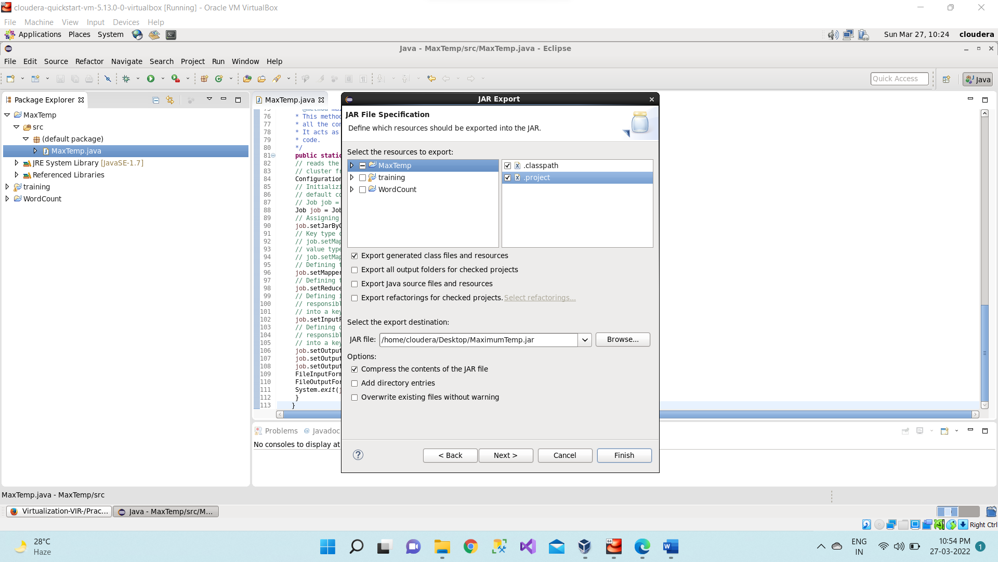

**Step 7:** Open terminal & type hdfs dfs -ls / command Here listing all the directory present in hdfs

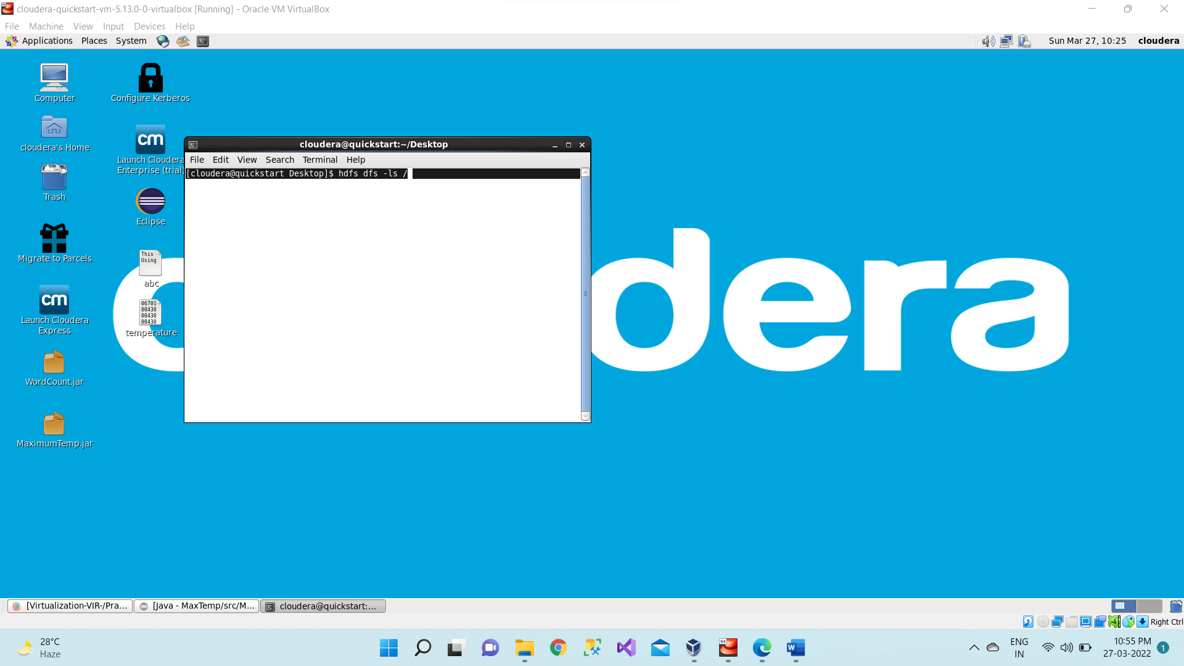

**Step 8:** Input file named as temperature which is present on desktop i.e., in local file system

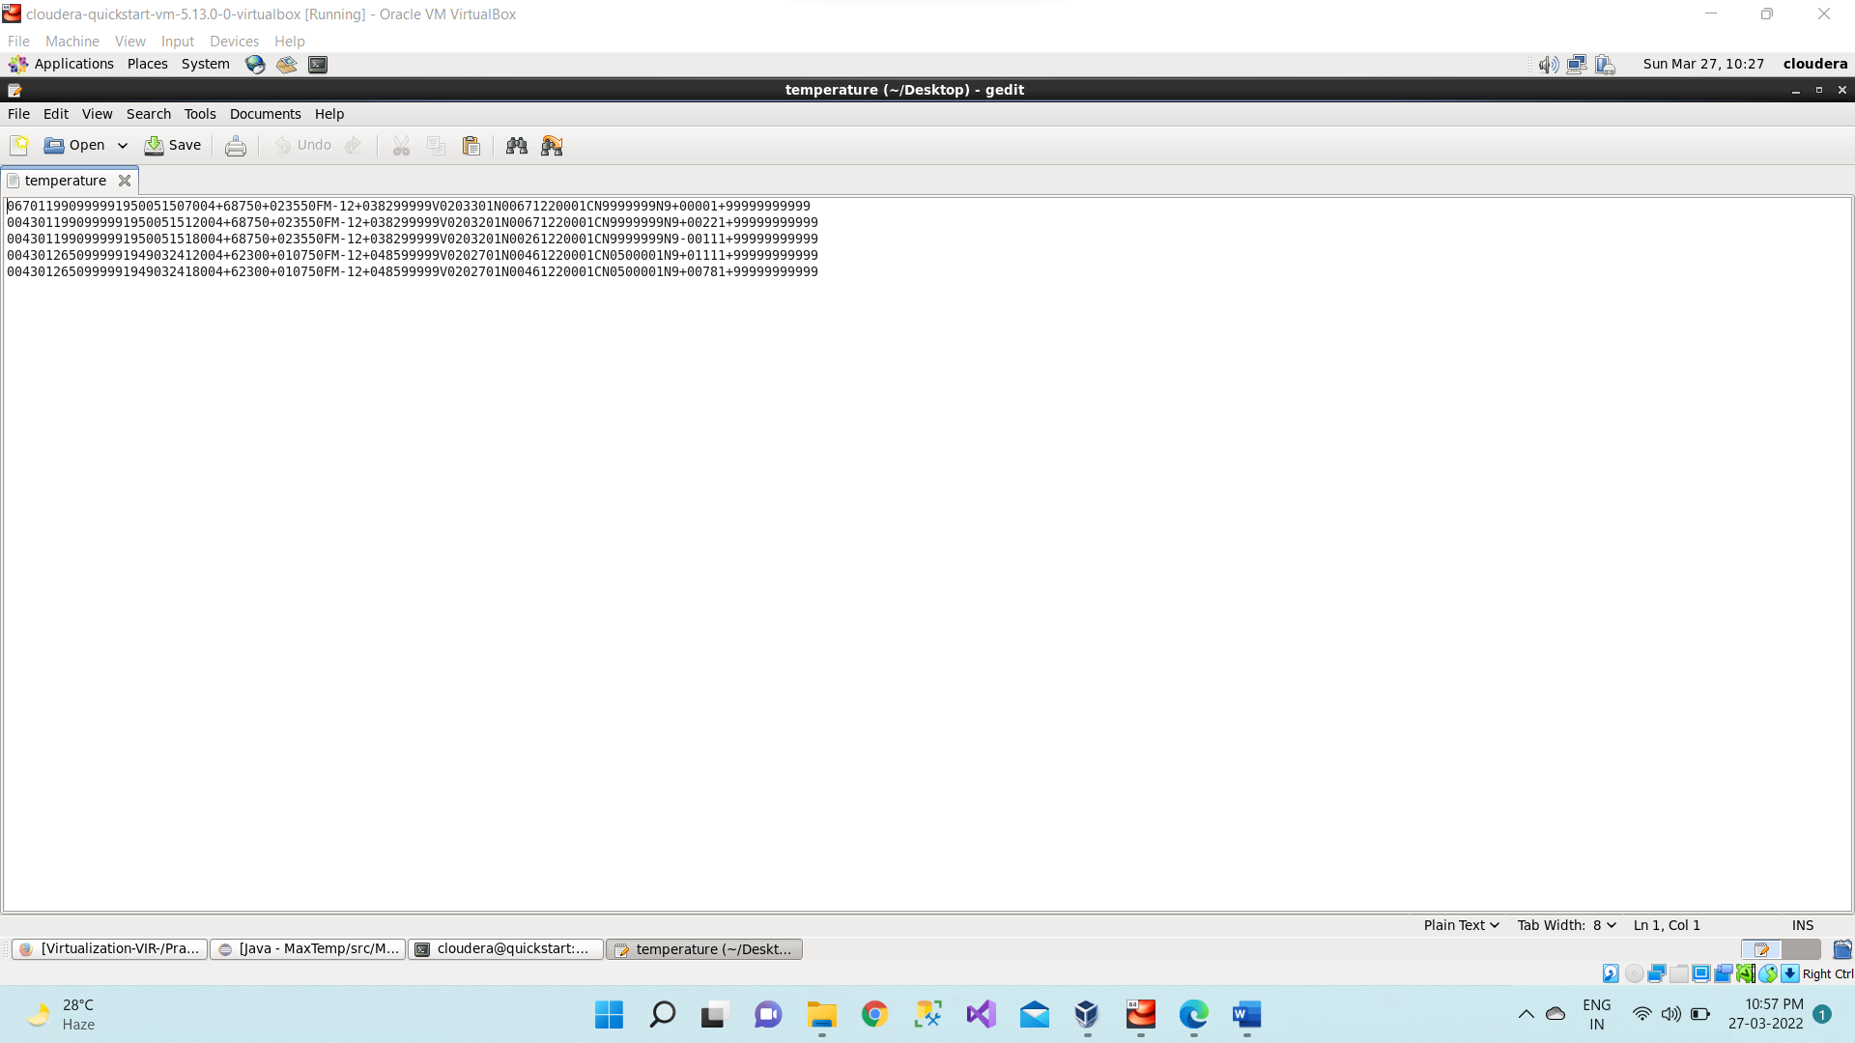

**Step 9:** Now we have to move this input file to hdfs. For this we create a direcory on hdfs using command hdfs dfs -mkdir /tempip.

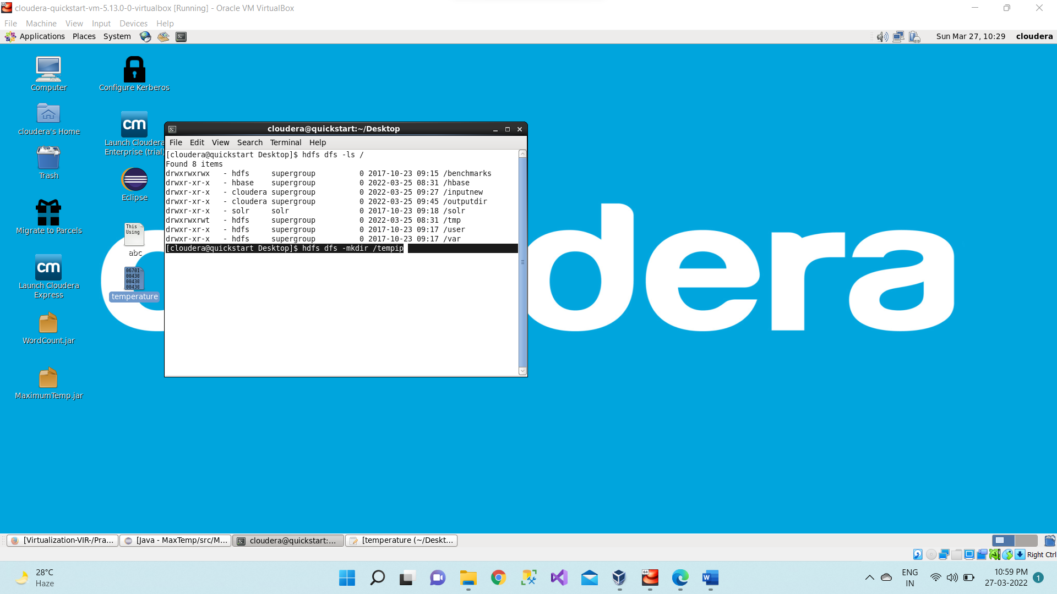

**Step 10:** Then we can verify whether this directory is created or not using ls command hdfs dfs -ls /

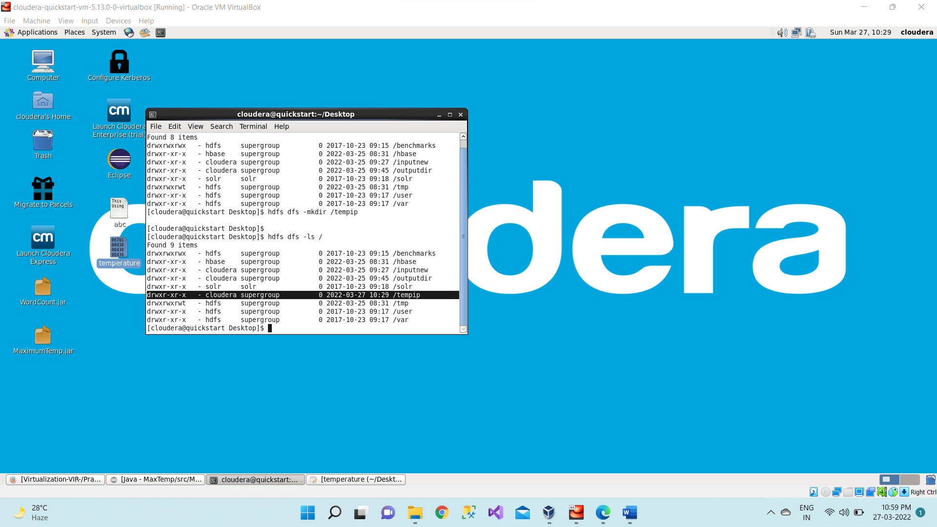

**Step 11:** Move the input file i.e., temperature to this directory created in hdfs by using either put command or copyFromLocal command.

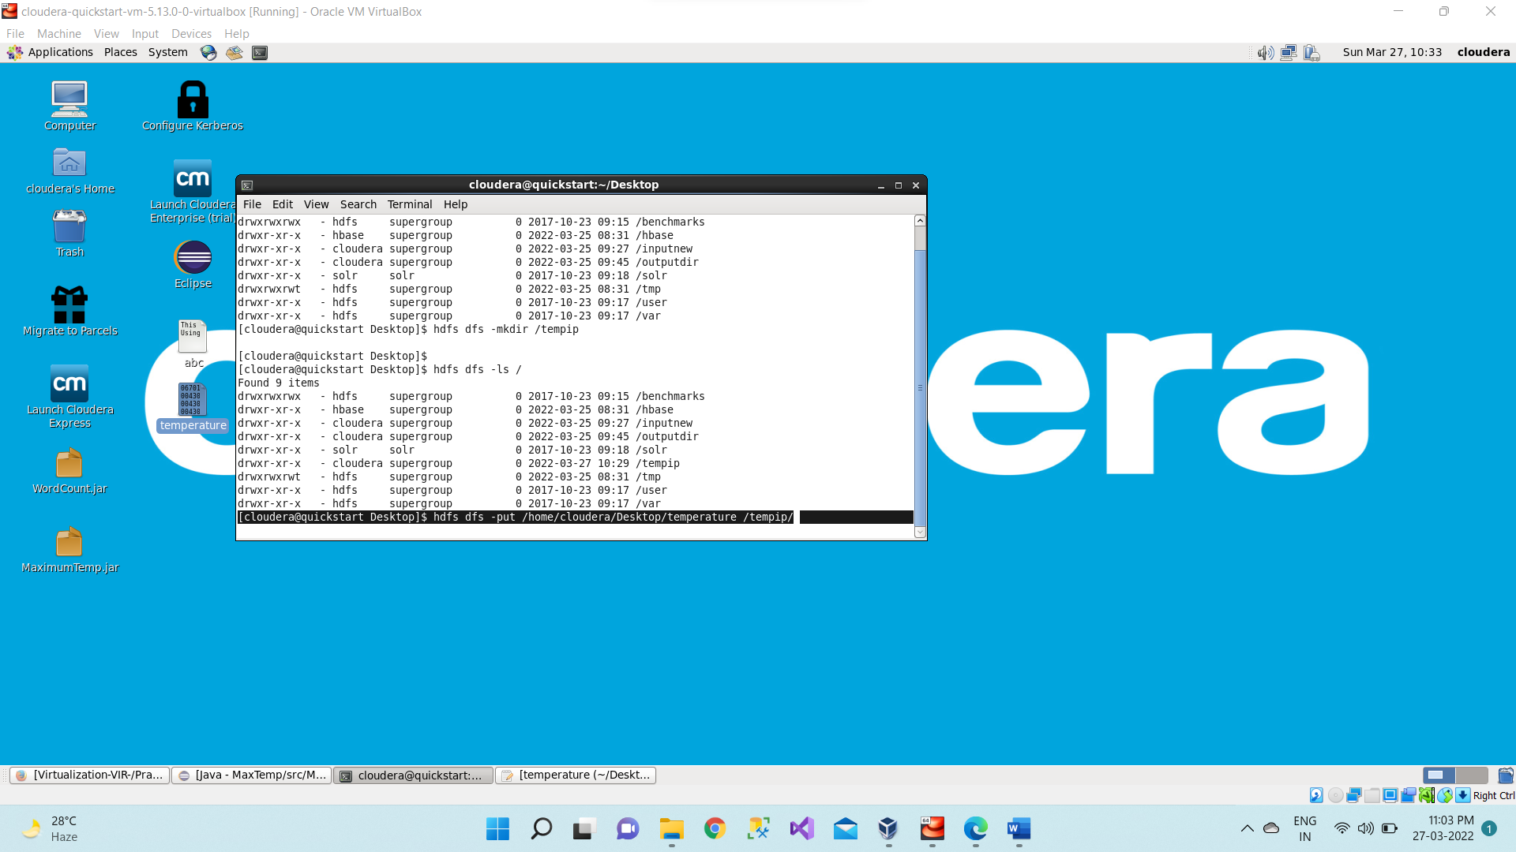

**Step 12:** Now checking whether the “temperature” present in /tempip directory of hdfs or not using hdfs dfs -ls /tempip command

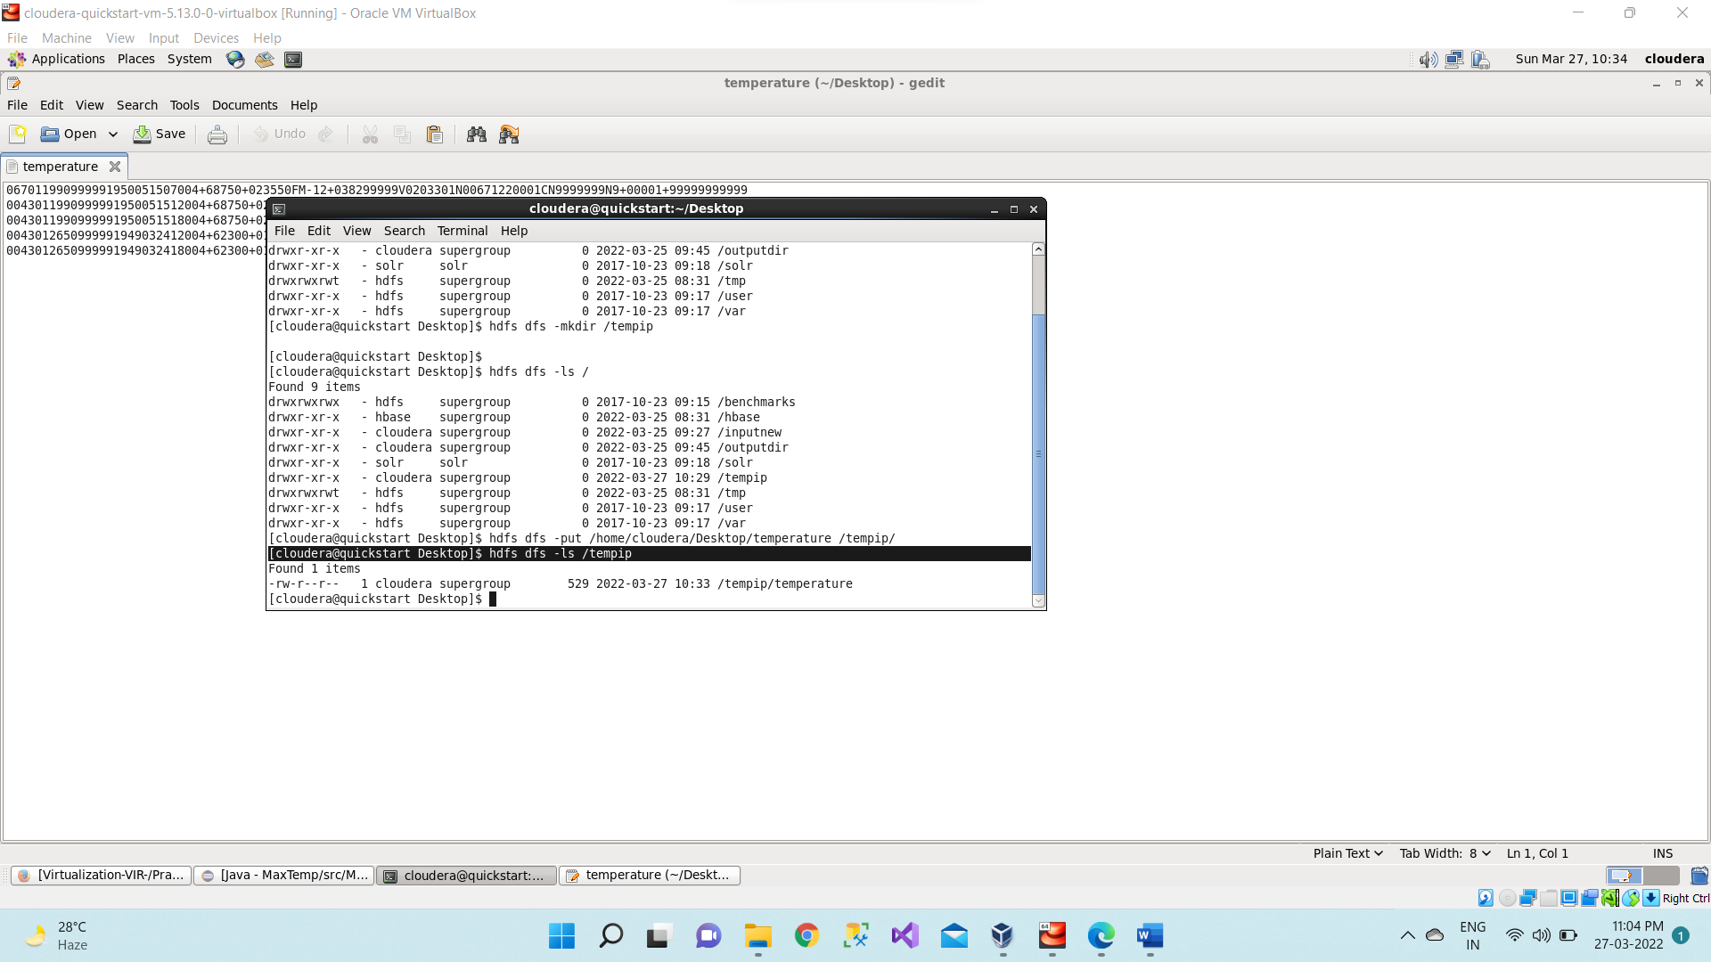

**Step 13:** As we can see “temperature” file is present in /tempip directory of hdfs. Now we will see the content of this file using hdfs dfs –cat /tempip/temperature command

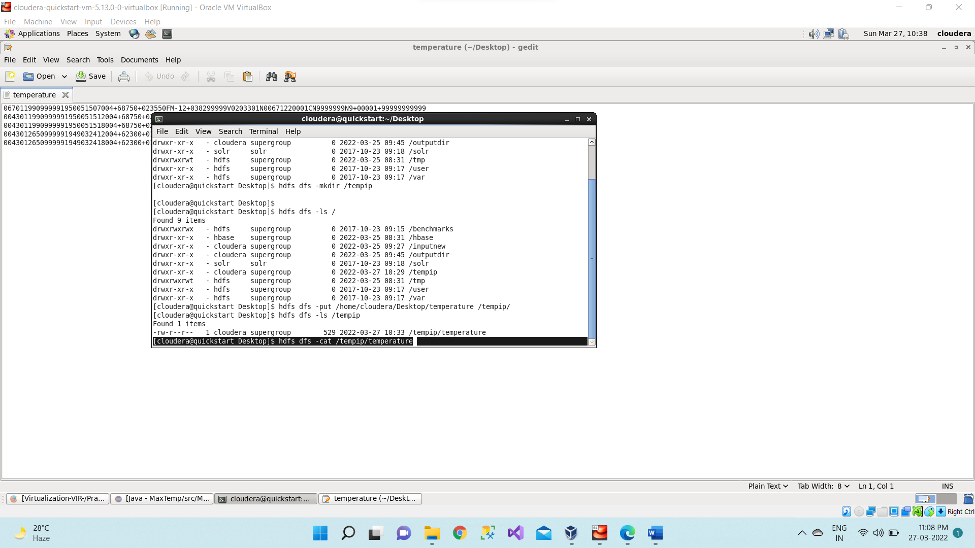

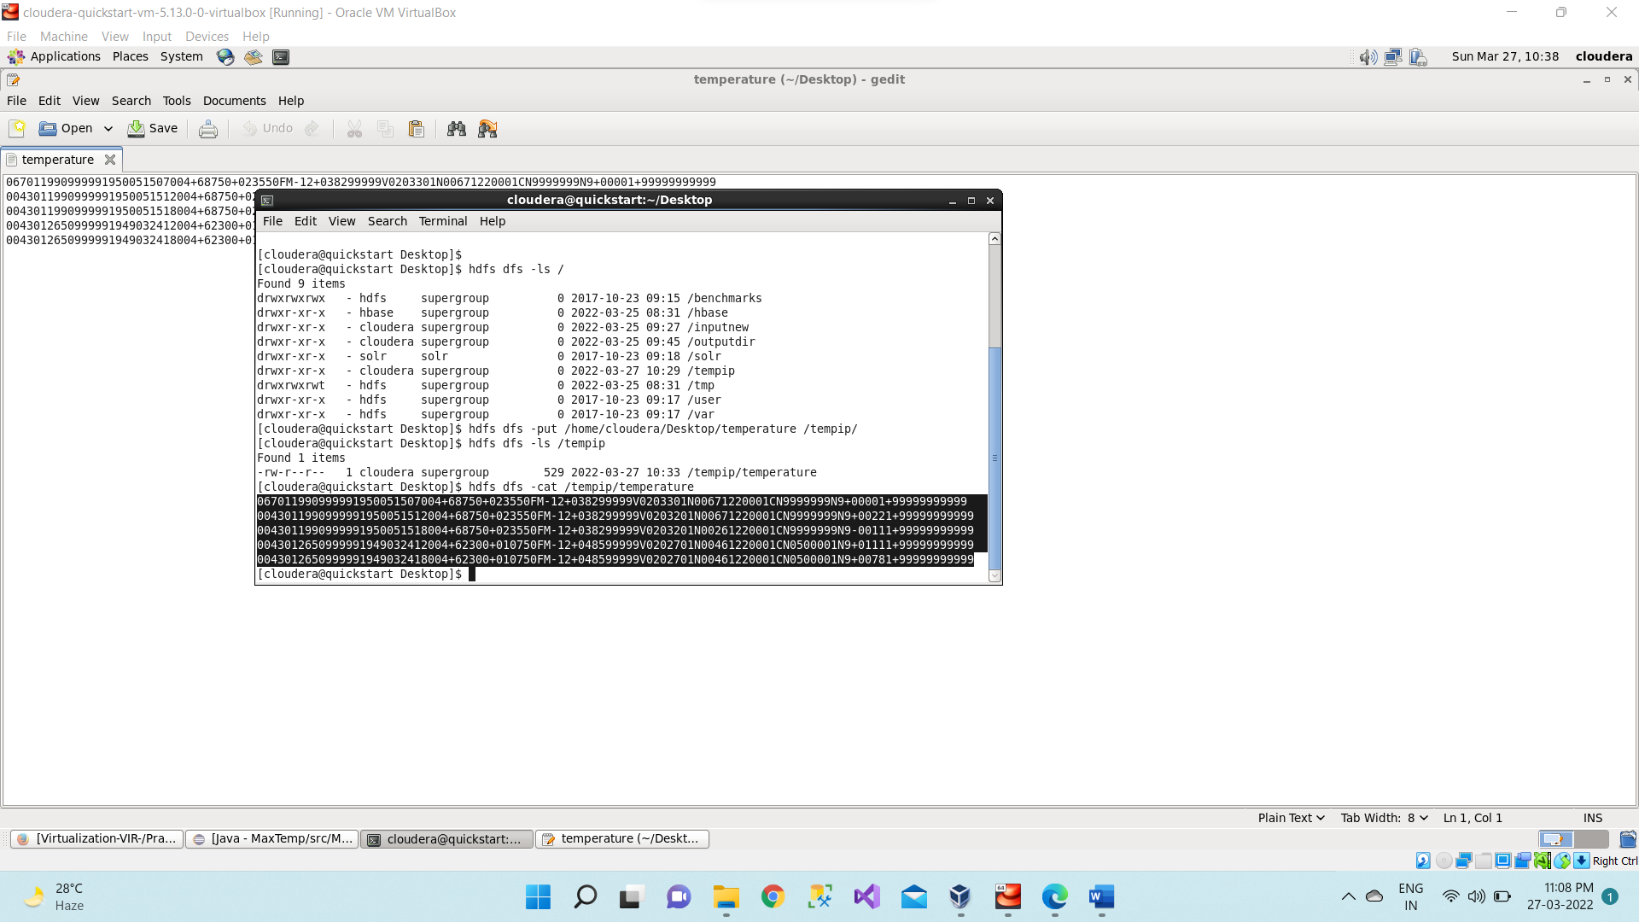

**Step 14:** Running Mapreduce Program on Hadoop, syntax is hadoop jar jarFileName.jar ClassName /InputFileAddress /outputdir

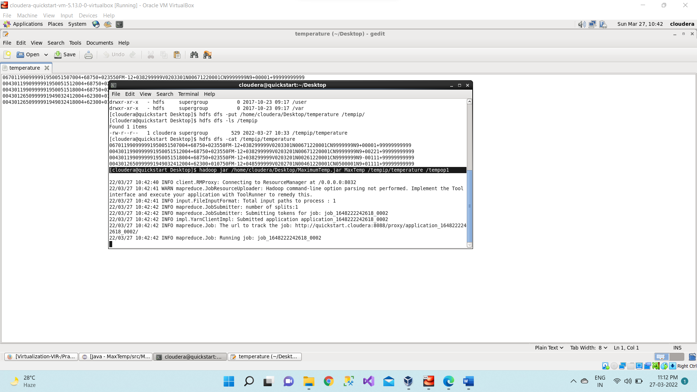

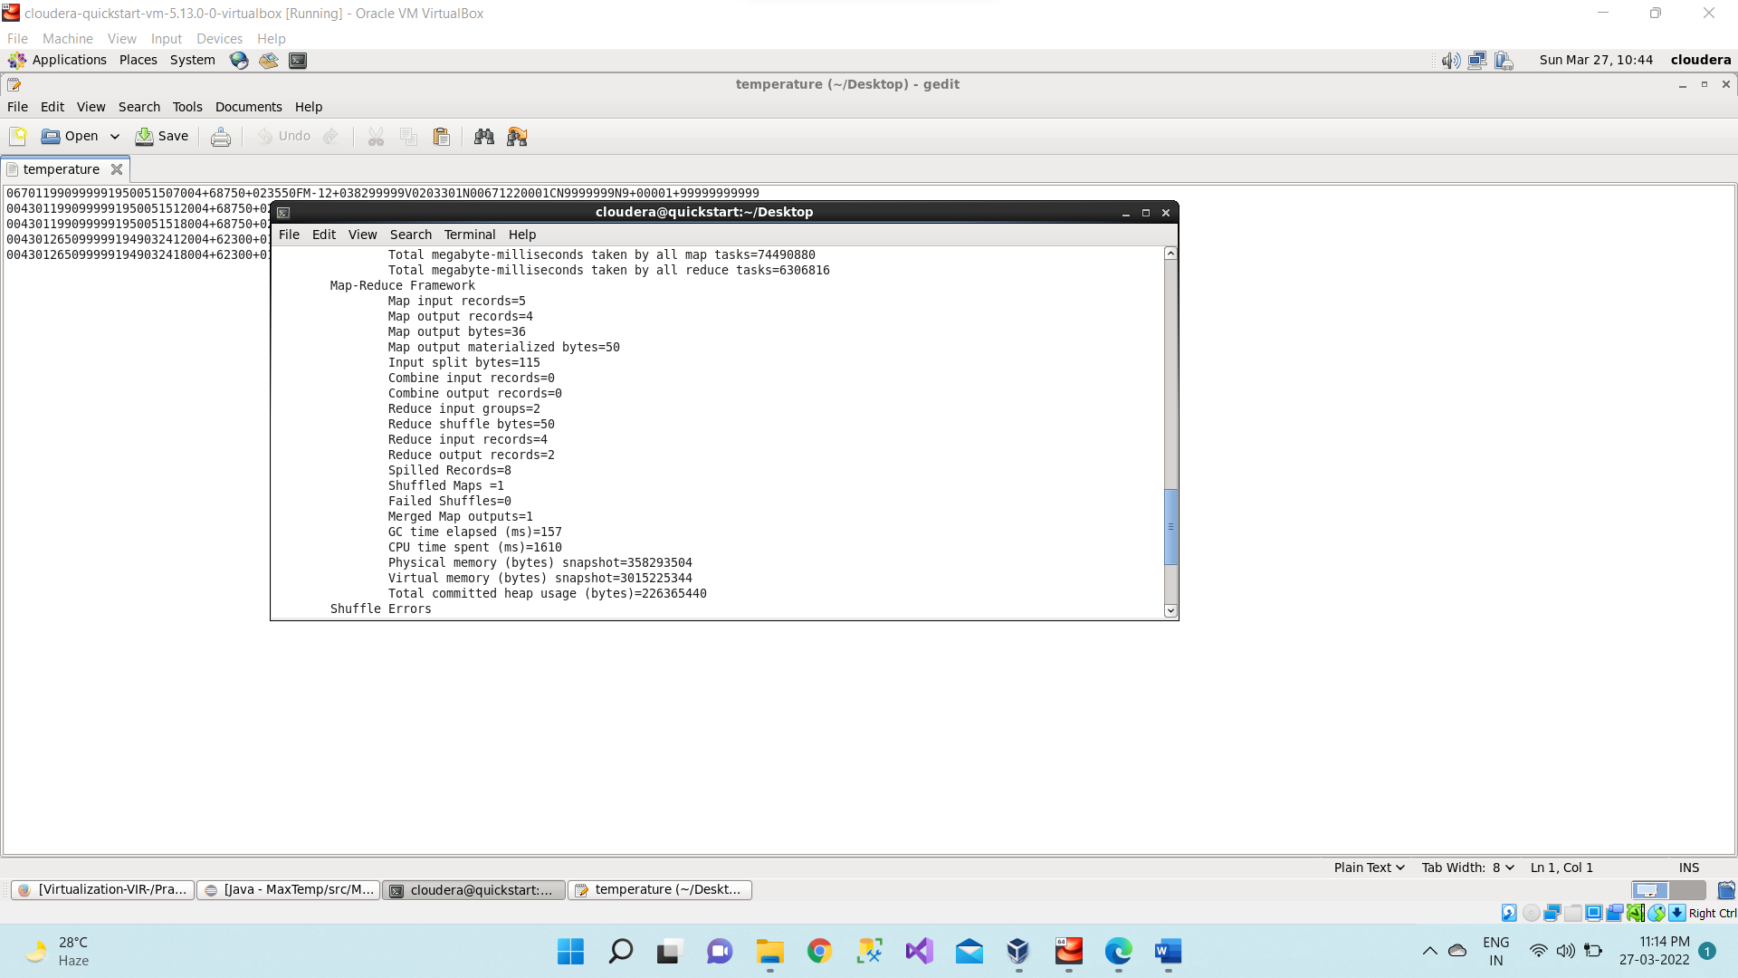

**Step 15:** Then we can verify the content of tempop1 directory and in that part-r file has the actual output by using the command Hdfs dfs -cat /tempop1/part-r-00000 This will give us final output. The same file can also be accessed using a browser. For every execution of this program, we need to delete the output directory or give a new name to the output directory every time.

1st we are checking whether the tempop1 directory is created in hdfs or not using command hdfs dfs -ls /

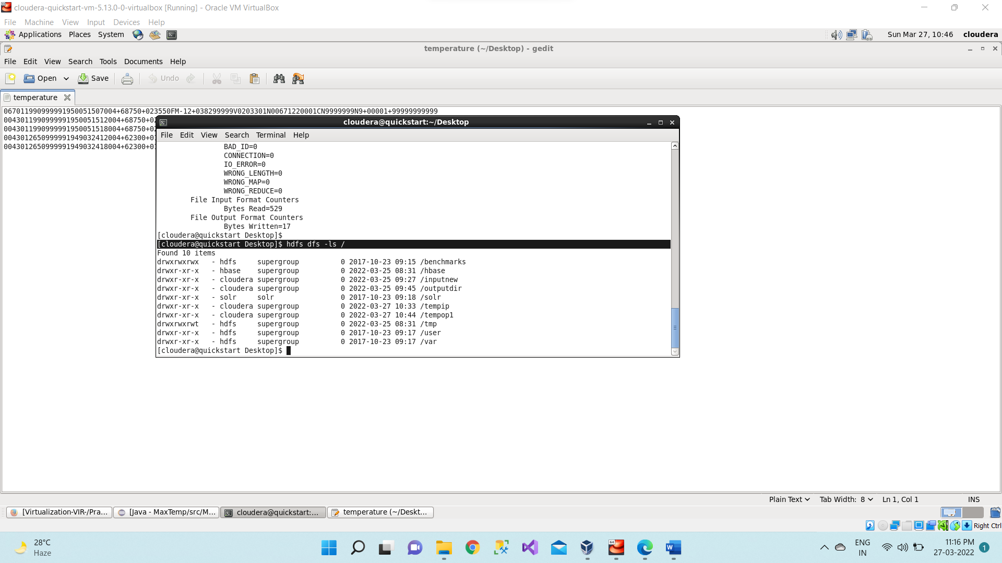

Now let’s check what we have inside this tempop1 directory using command as hdfs dfs -ls /tempop1

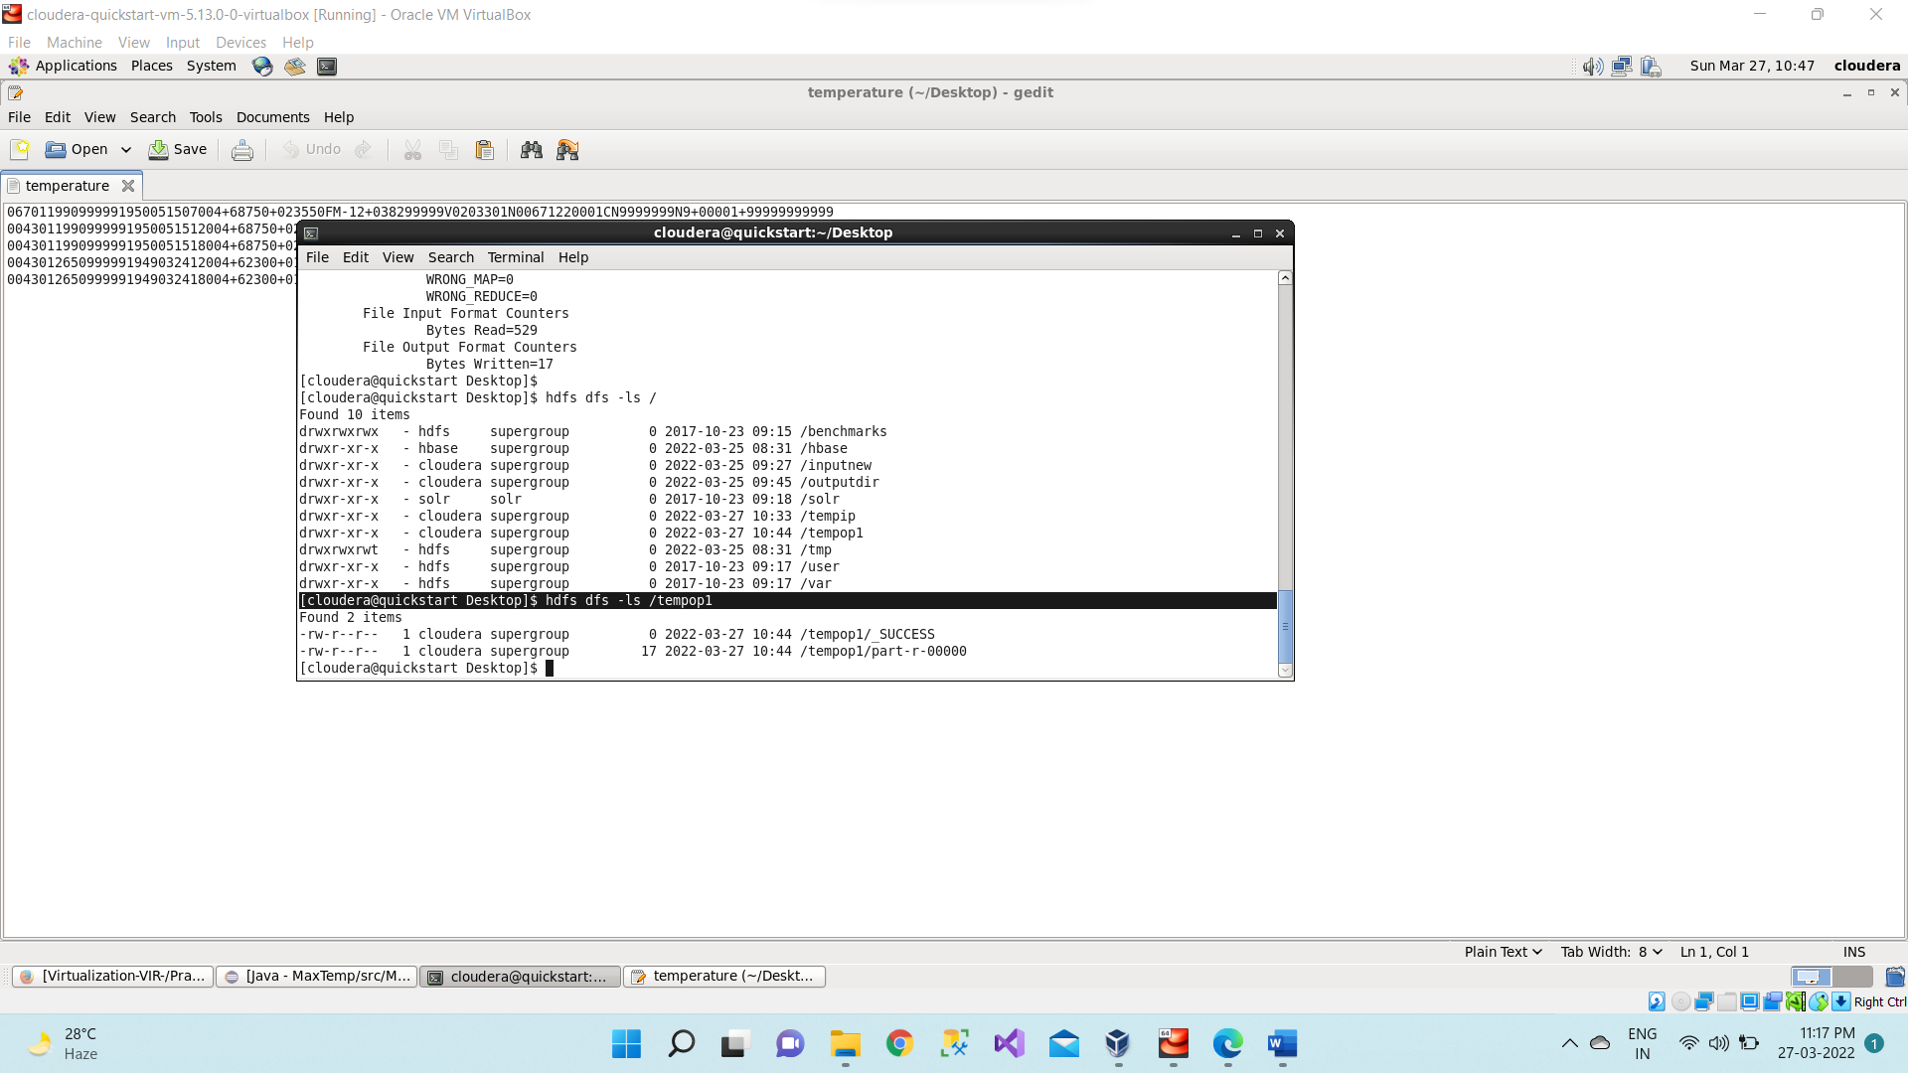

Now we want to read the content of the part-r-00000 file which present inside the tempop1 using command hdfs dfs -cat /tempop1/part-r-00000

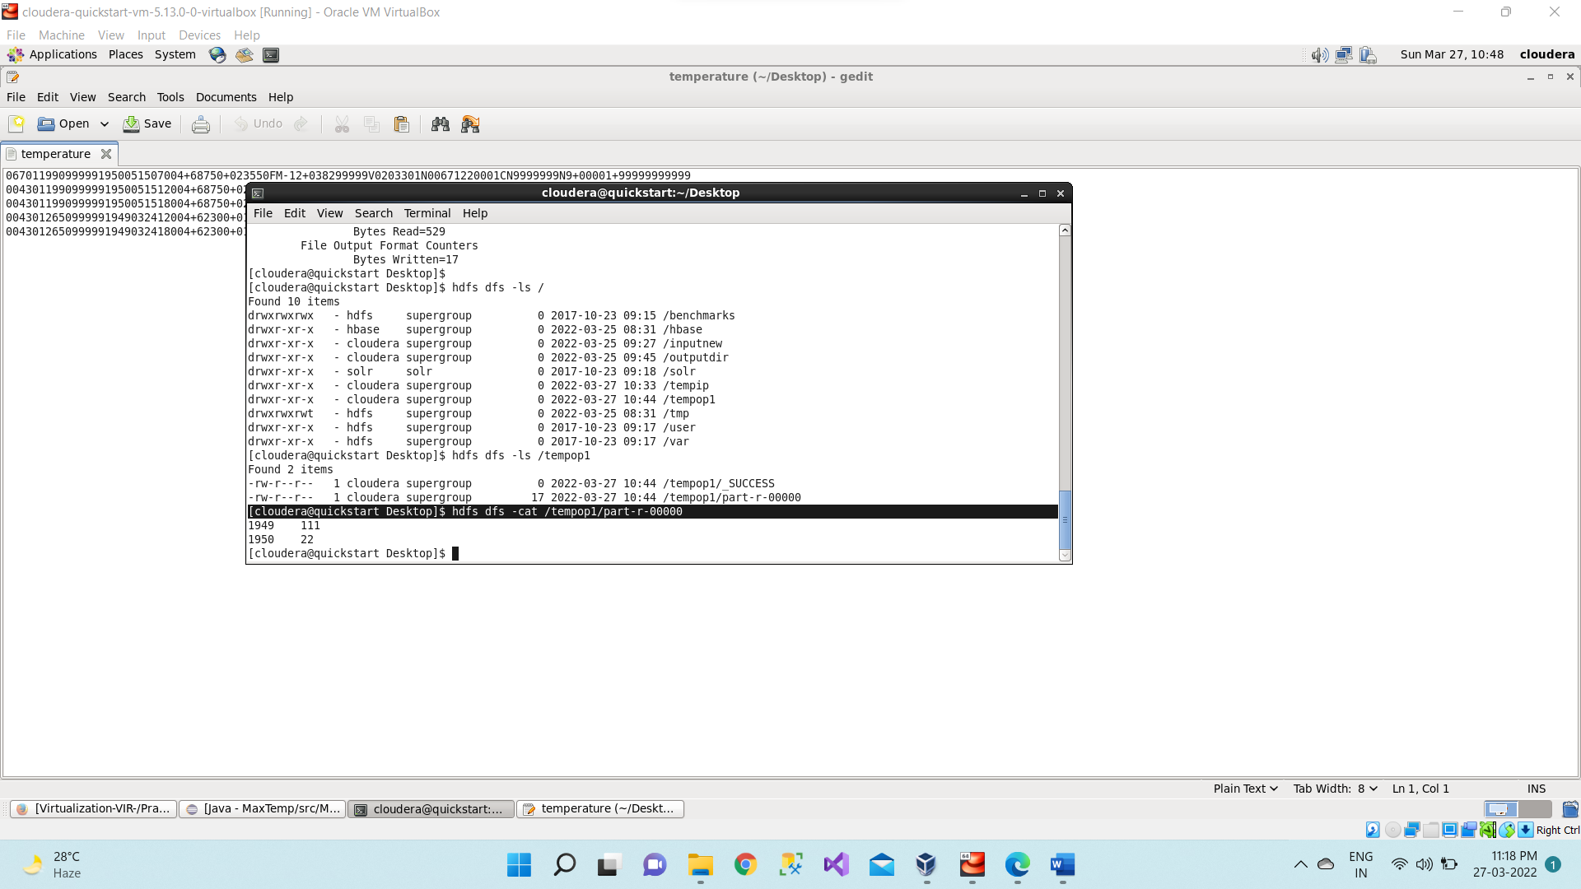

So, the maximum temperature for the year 1949 is 111 and for the year 1950 is 22

The same file can also be accessed using a browser.

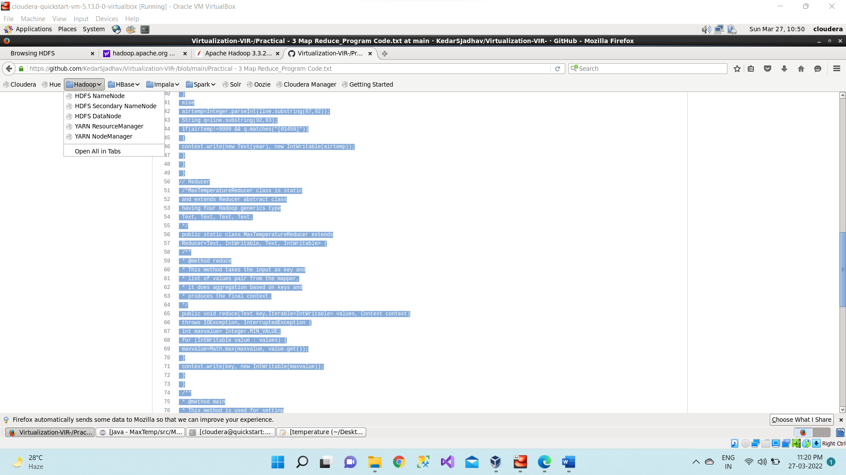

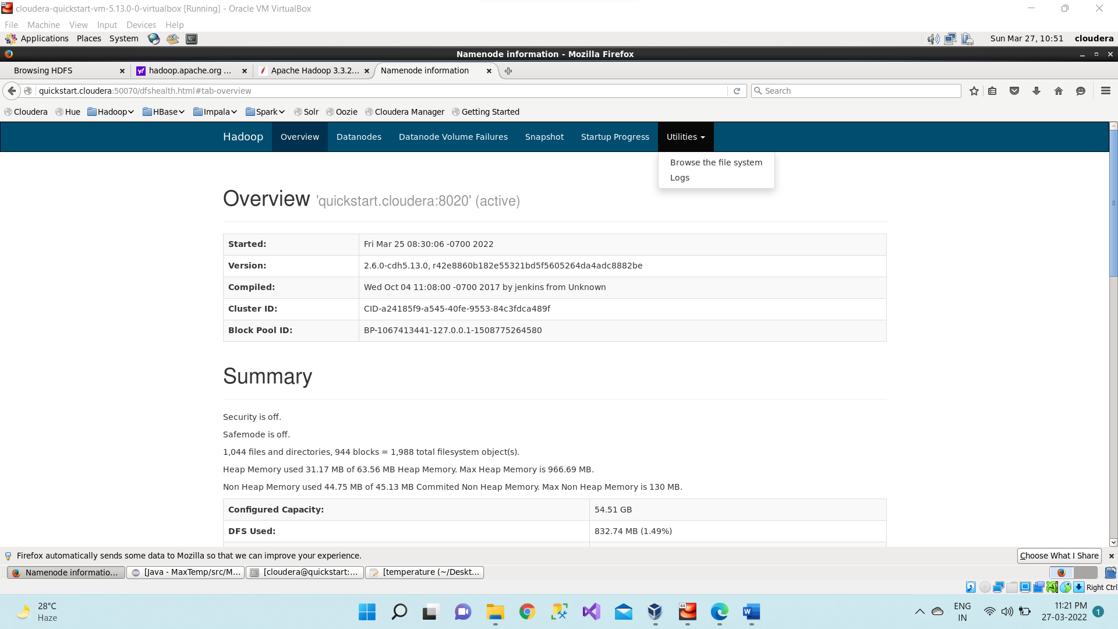

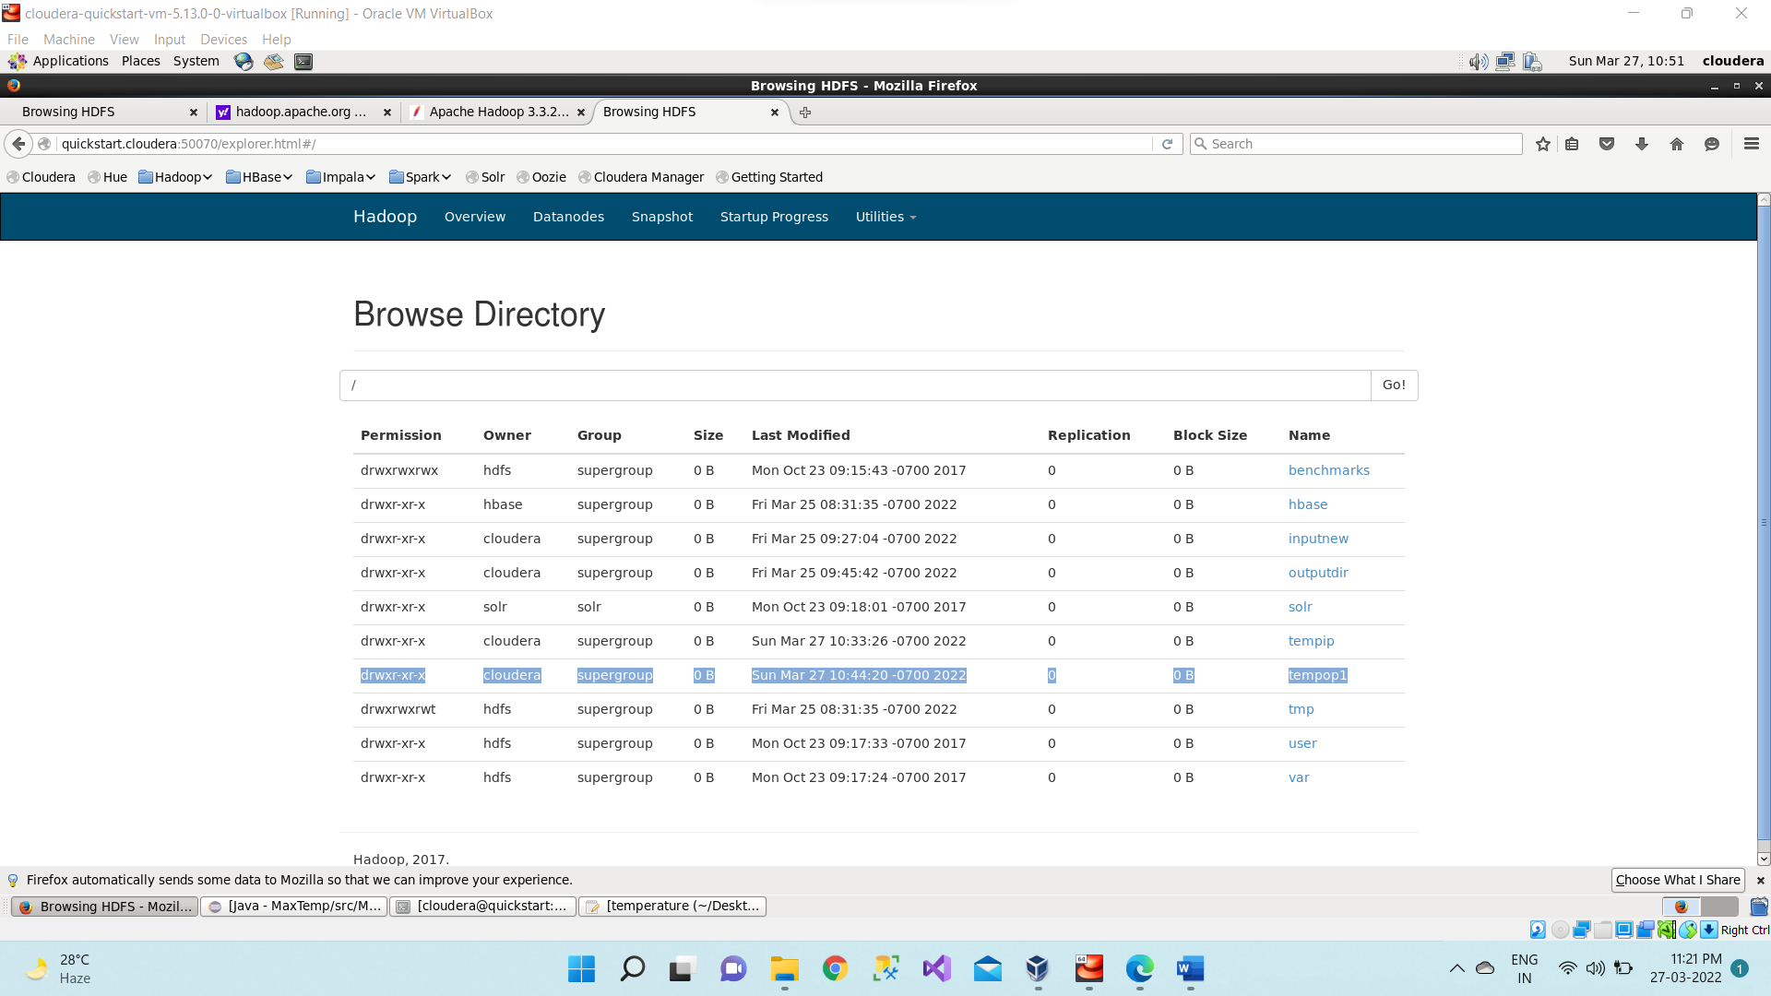

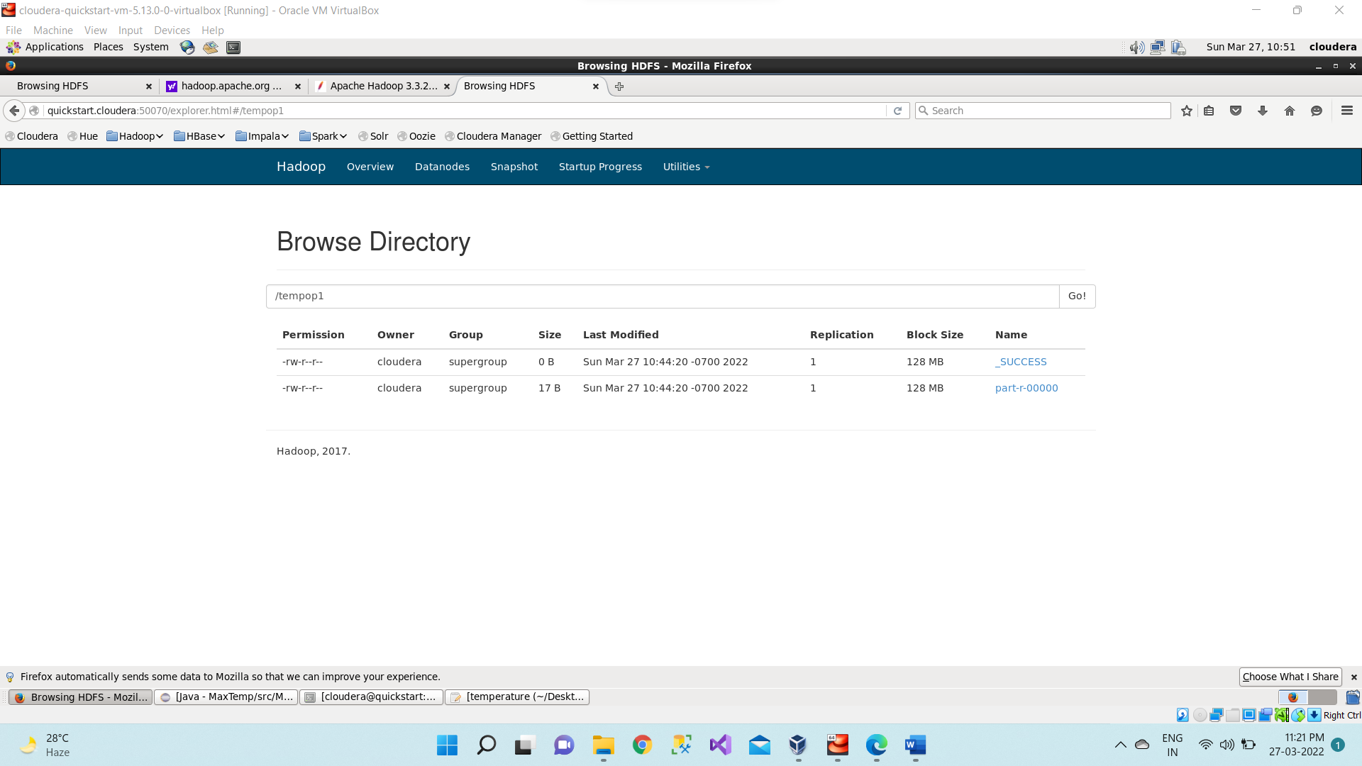

Now downloading the part-r-00000 file.

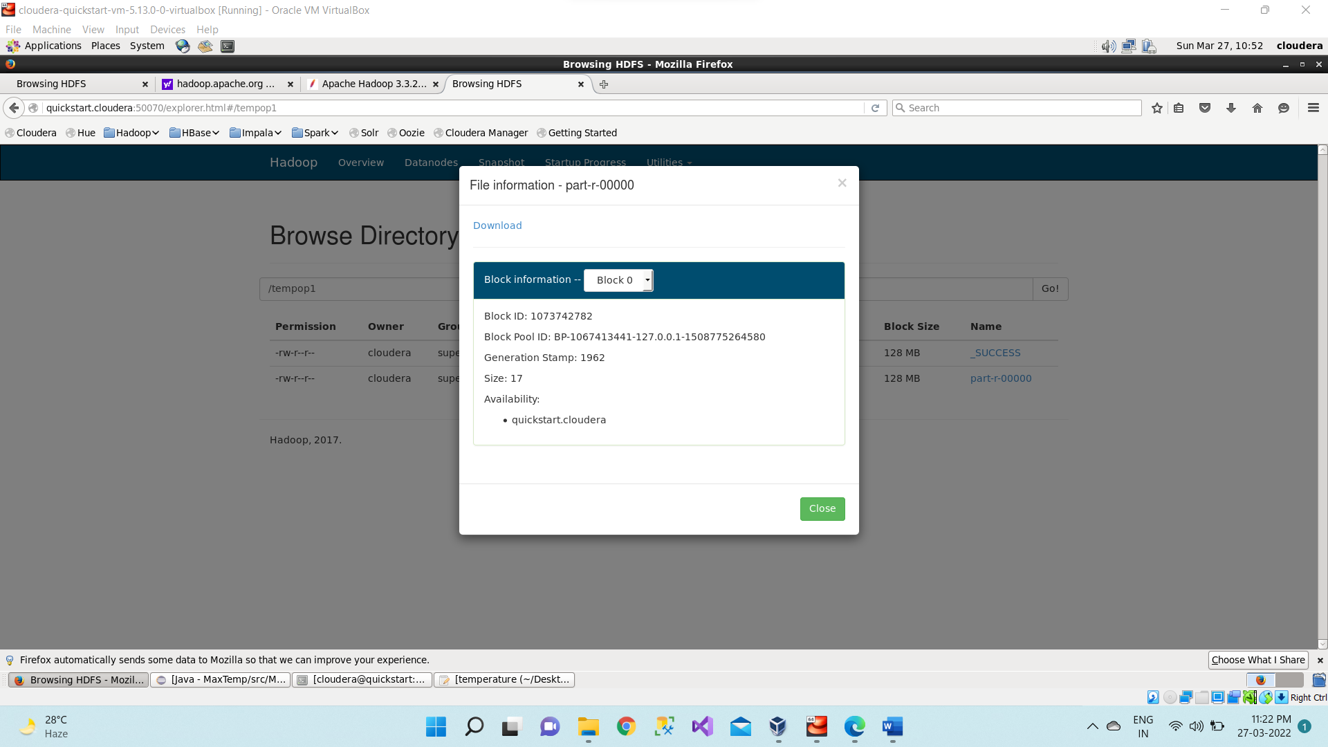

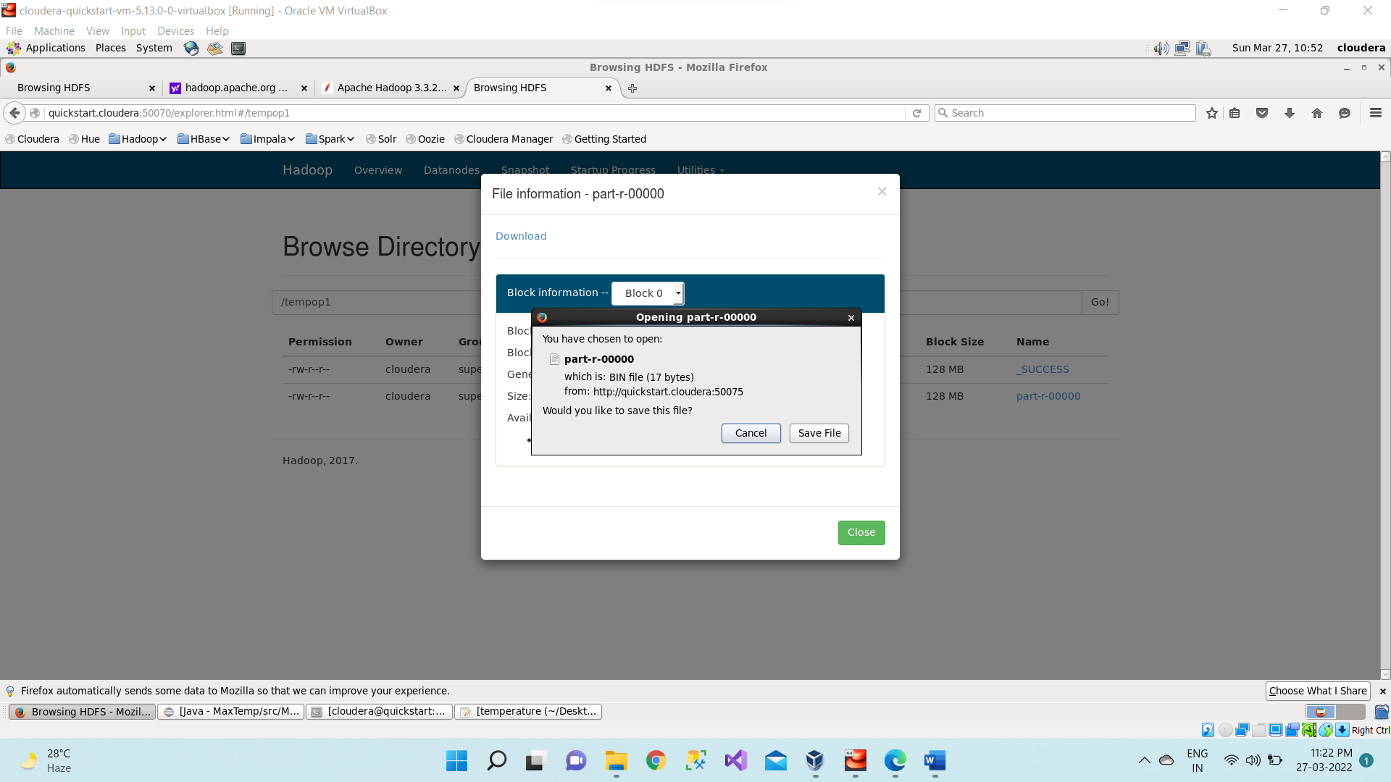

Inside the part-r-00000 file it will have the same output as we are getting after executing using command. hadoop jar /home/cloudera/MaximumTemp.jar MaxTemp /tempip/temperature /tempop1

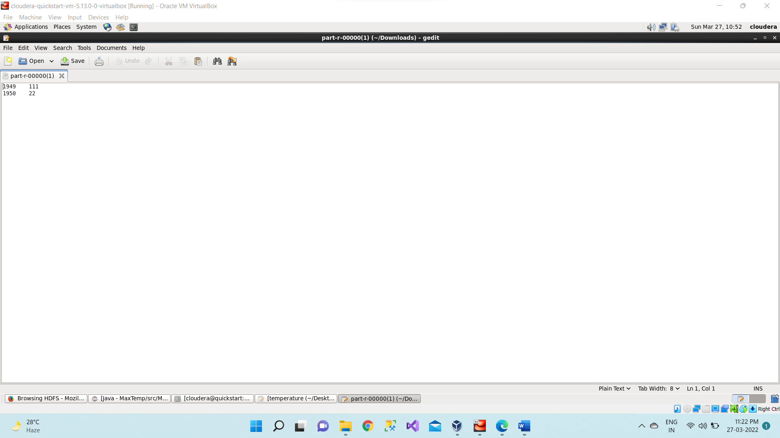

For every execution of this program, we need to delete the output directory or give a new name to the output directory every time